Starting the server

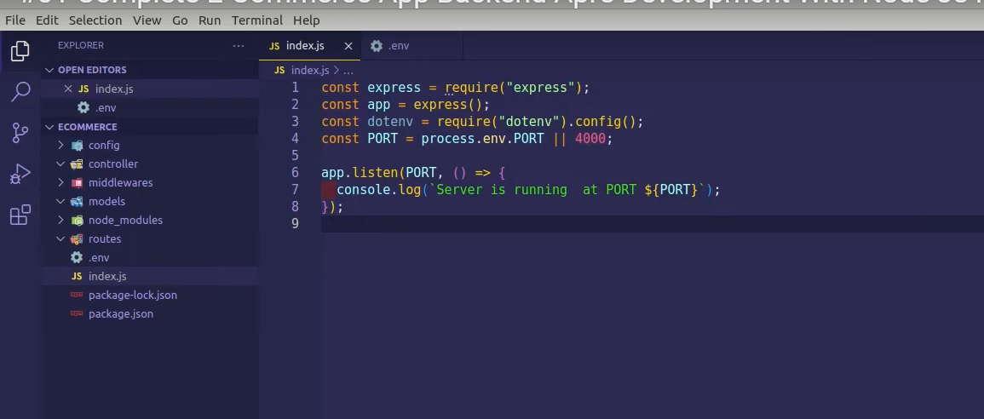

Connecting with database

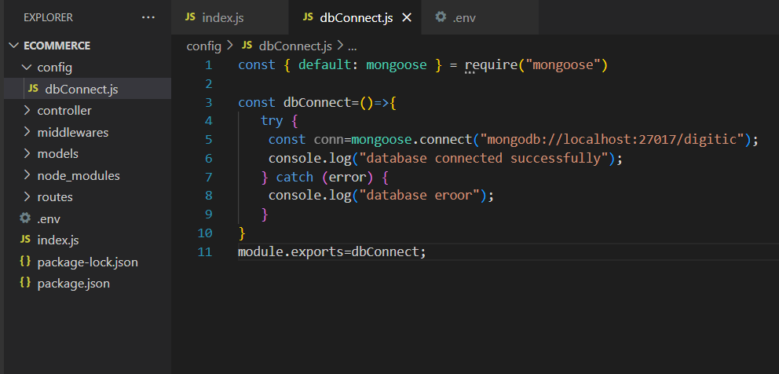

Just call the database in index js like dbConnect()

Creating schema using mongodb extension use mdbg and hit enter in userModel

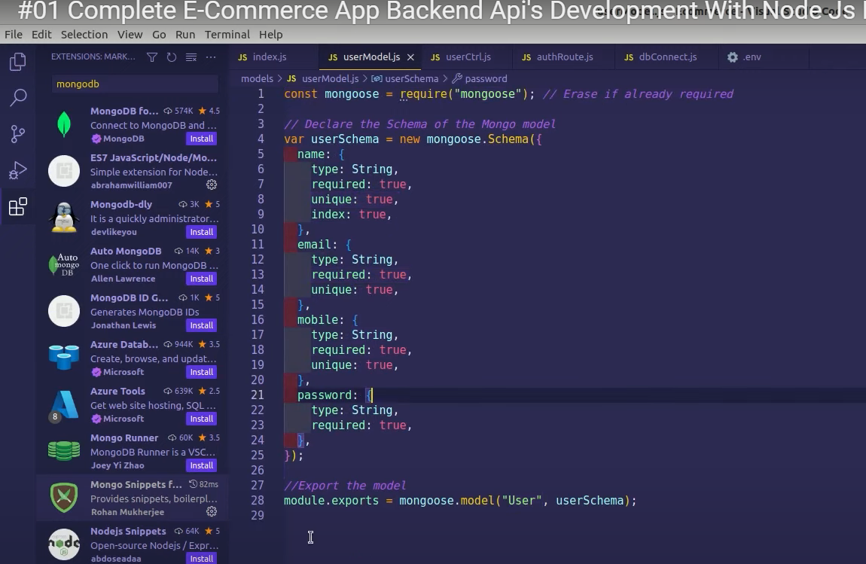

Creating of routes

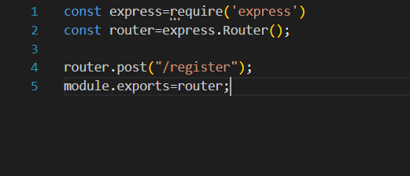

After amking auth route declare it in index js as done on line 6,12

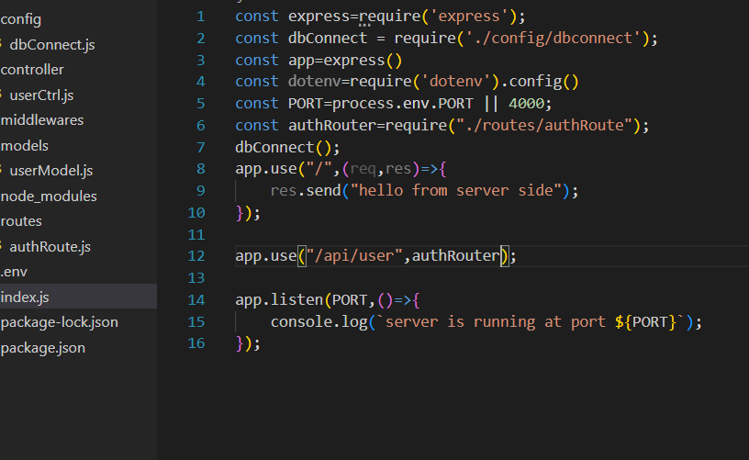

Now in controller part we will link auth and userctrl

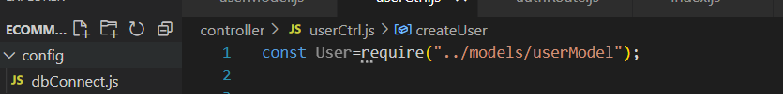

Now in Userctrl part we will create and check the exiting user

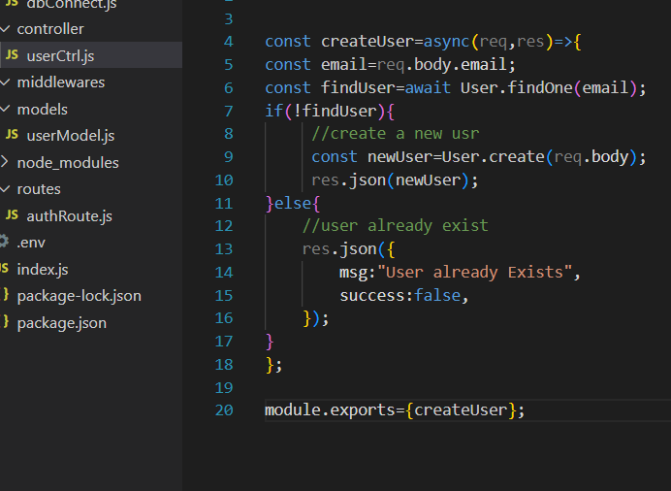

Just write creatUser in line 5 as shown

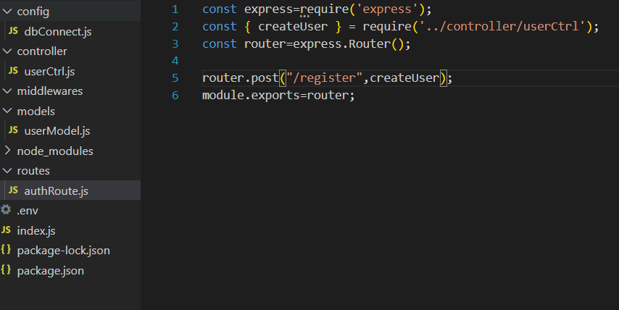

Before using postman update index.js

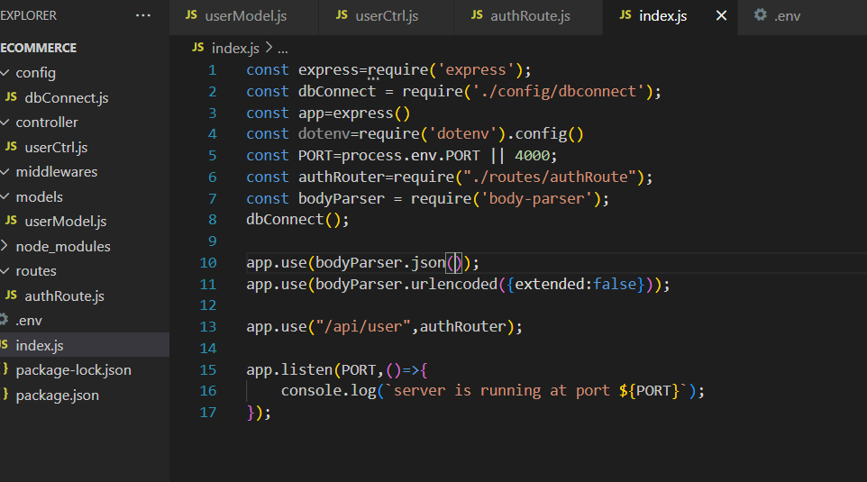

Use thund client from vs code to send request by changing local host to 127.0.0.1:5000

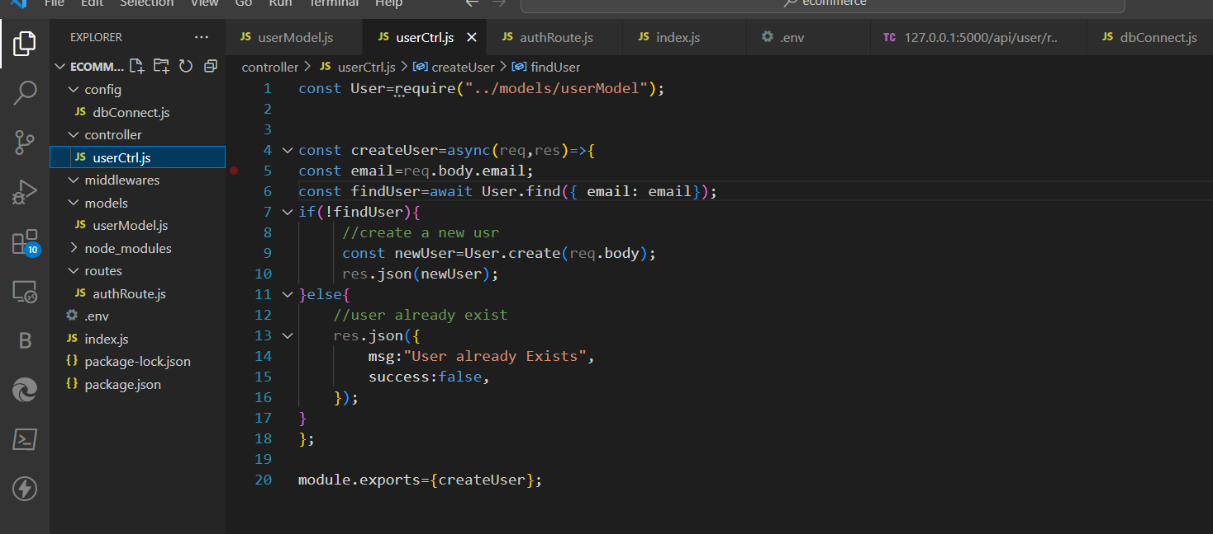

Use await on above pic line 9

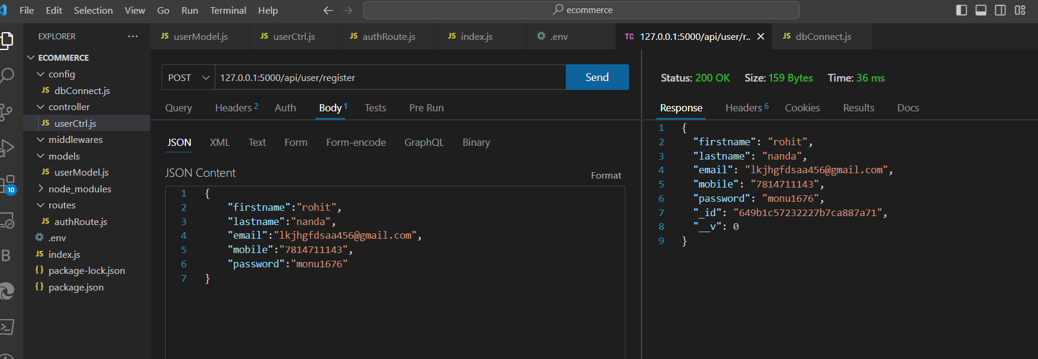

Error handiling part is now starting create a error handle file in middleware for this and do as shown below

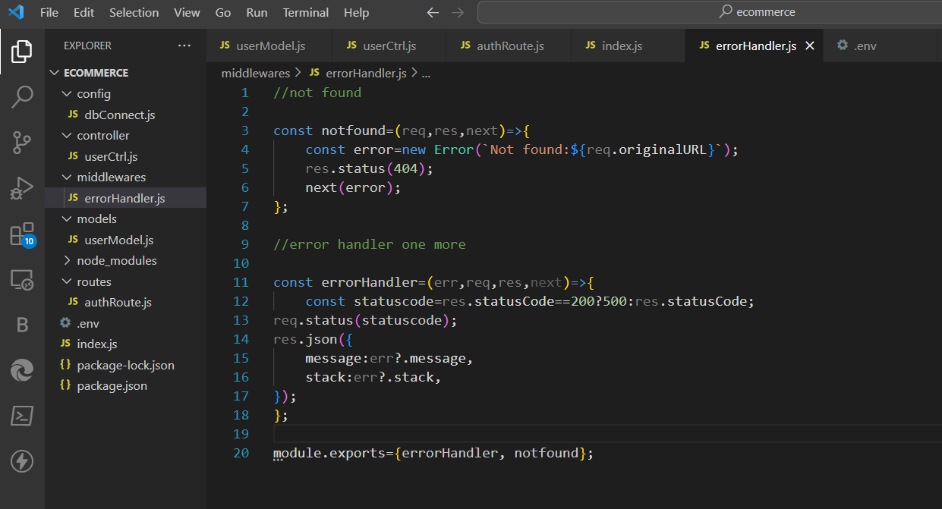

And on line 17,18 call this middleware like this

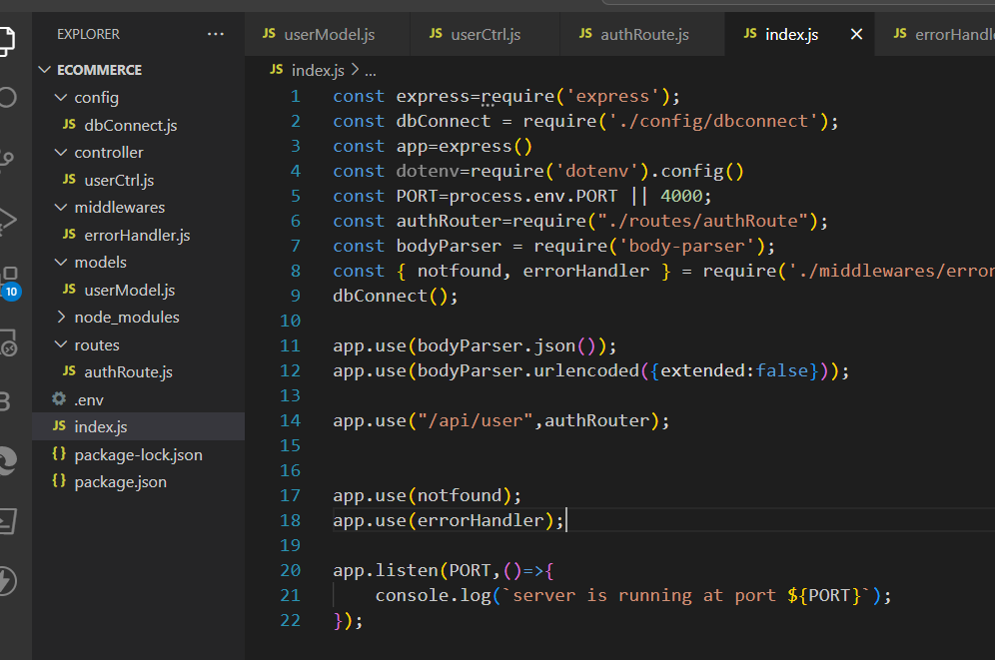

Now install this package using this command in terminal npm i express-async-handler

Now in controller part again do as directed

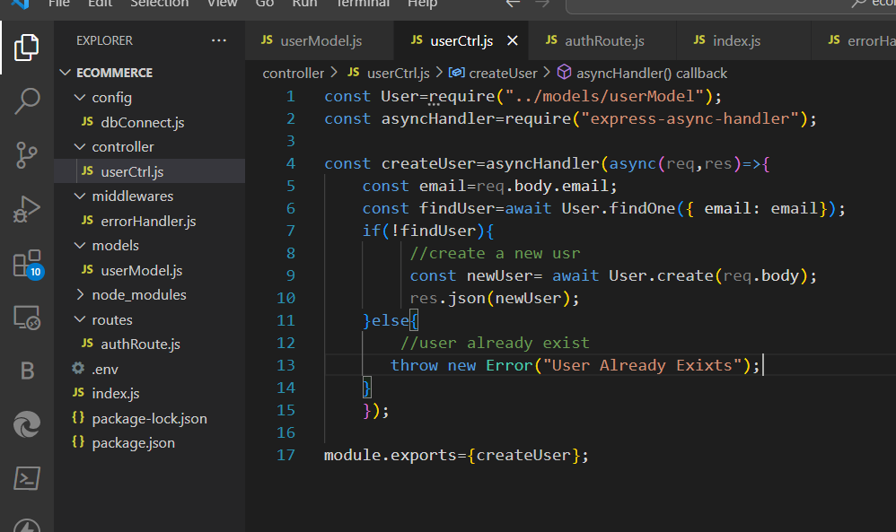

Now lets encrypt password using bcrypt install using npm i bcrypt

Now move to userModel and do as directed

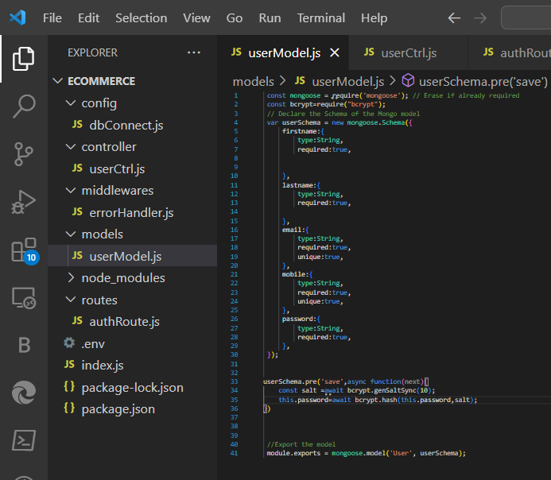

Create login controller in userctrl line 19-22

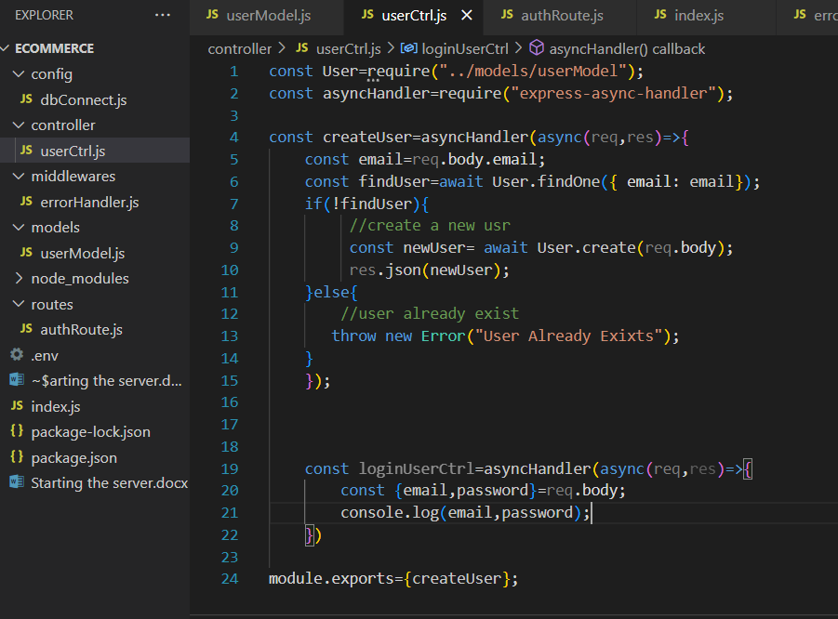

Now we need to create a route for this login controller line 6

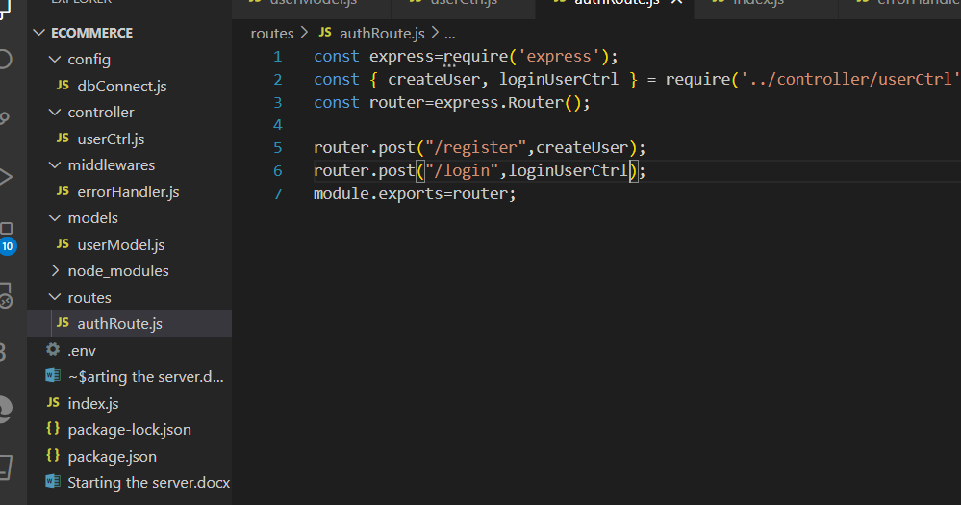

Back to userctrl and finding user exists or not line 21-27

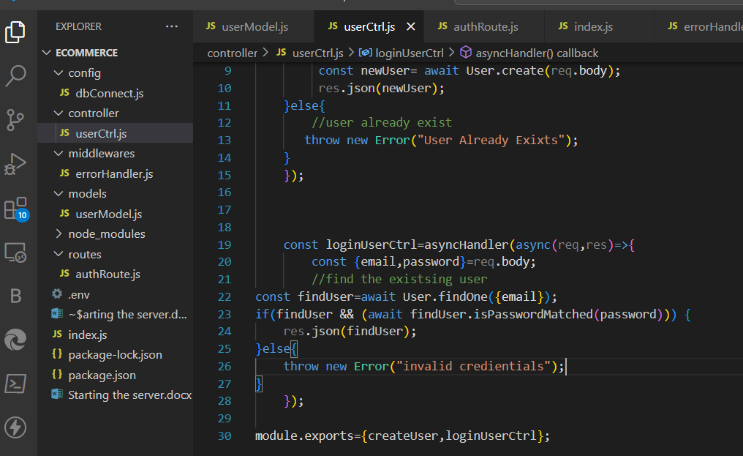

Install npm webtoken npm I jsonwebtoken

Now move to config folder and make a new file jwtToken.js

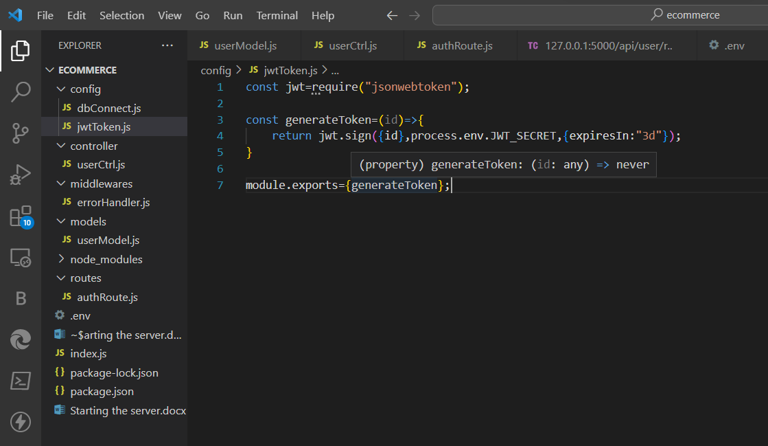

Again go back to userctrl

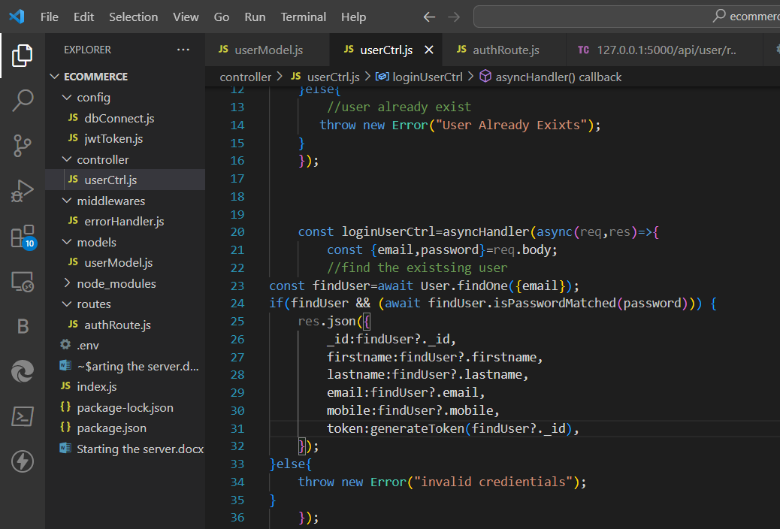

And update the usermodel

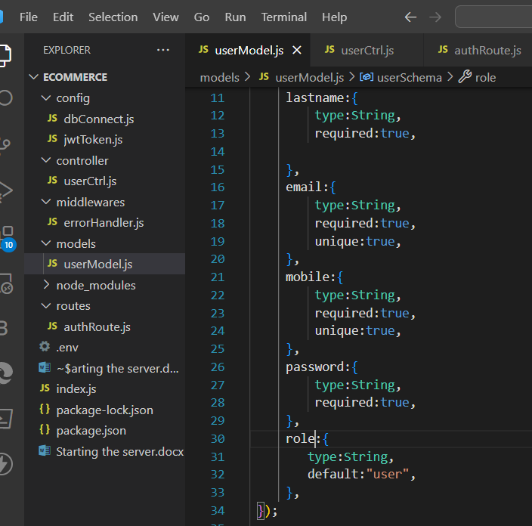

How to update,delete and fetch the user next functionality

Move to userctrl

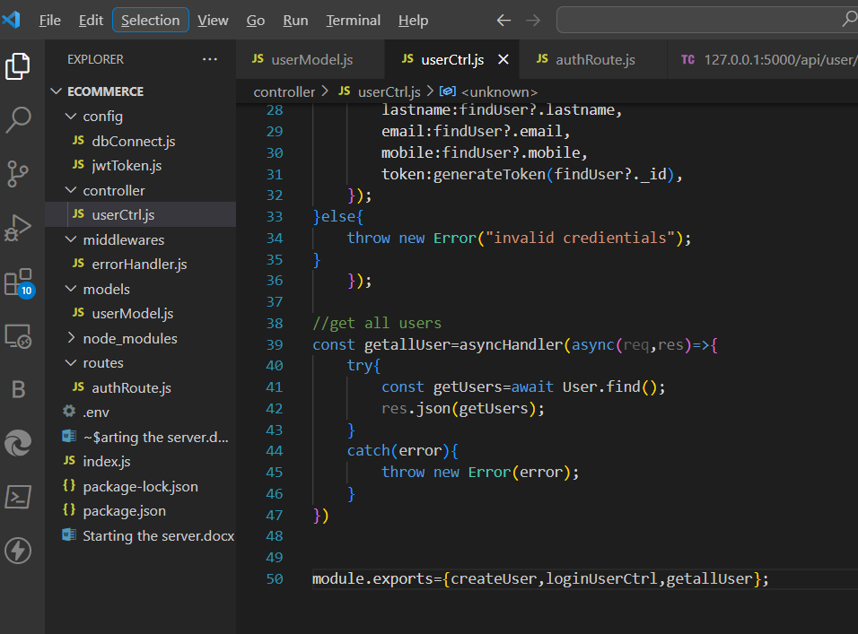

Add the route of above controller also

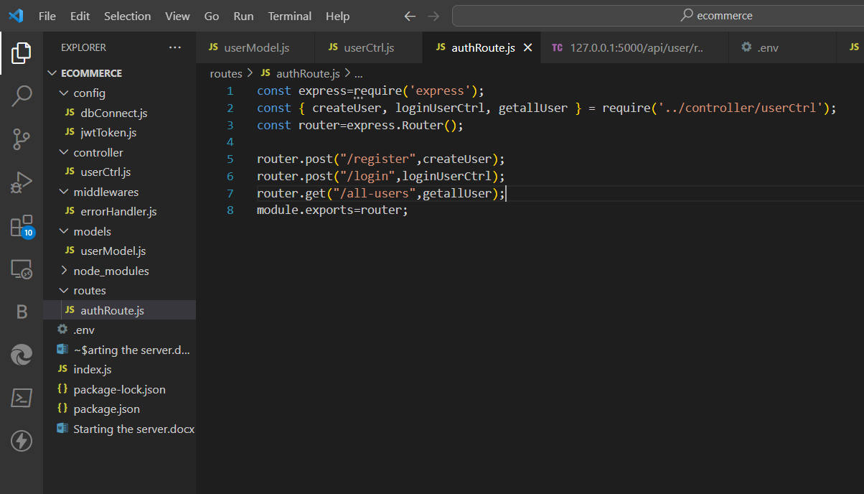

Get a single user line 48 also add it to modeule eport part

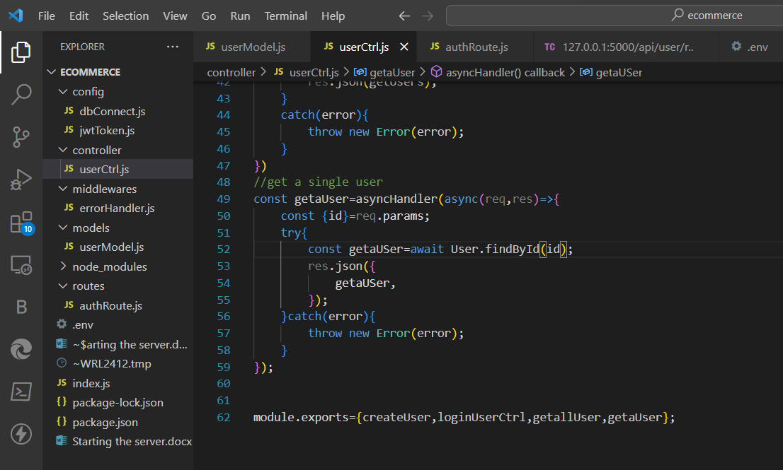

Now create the route for the same line-8

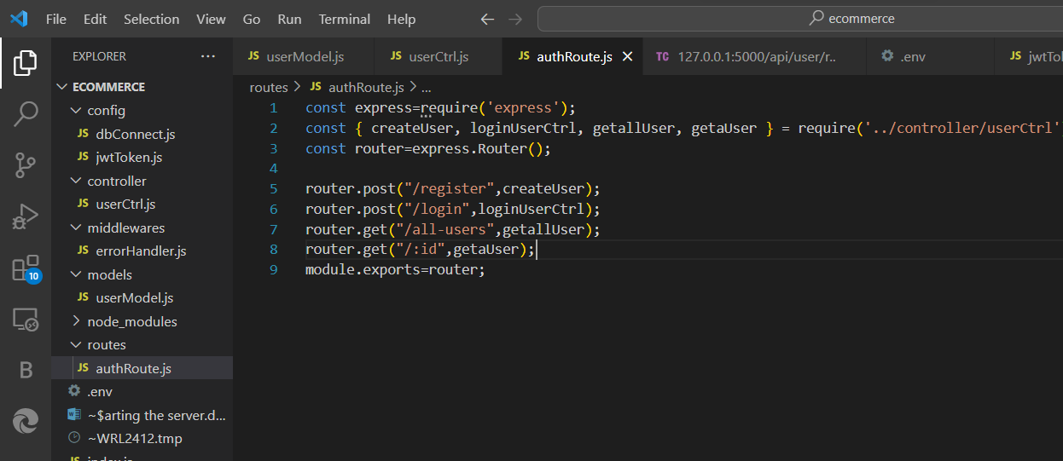

Deleting a usr

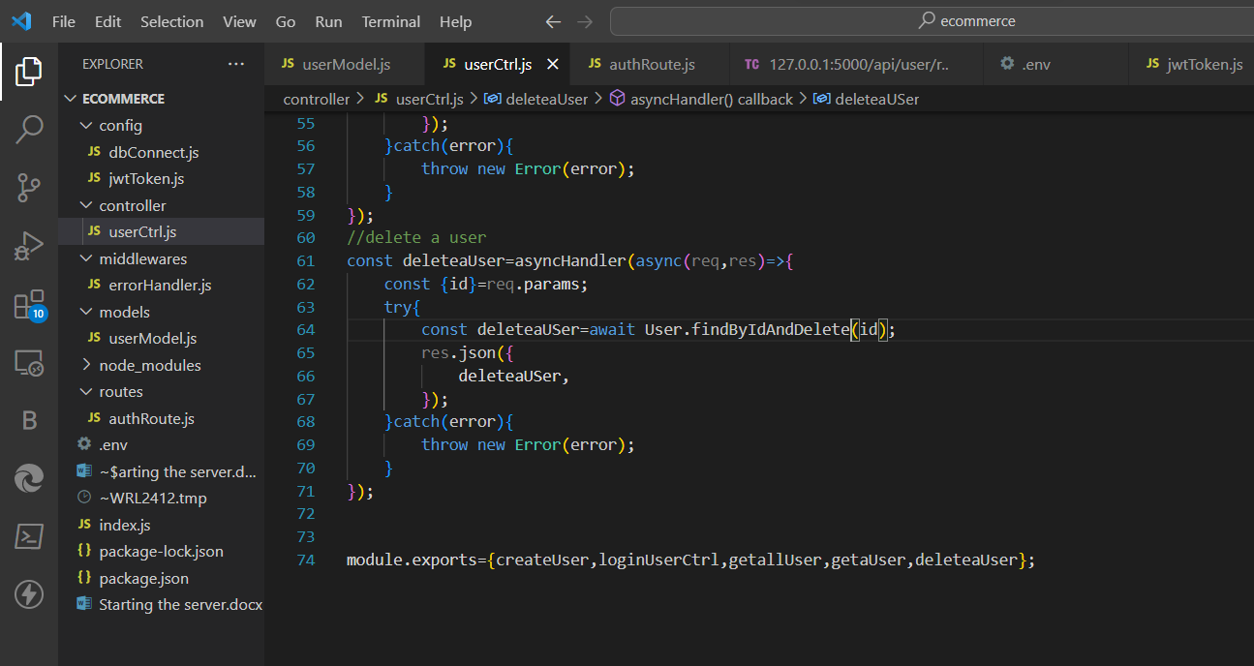

Creating a route for this

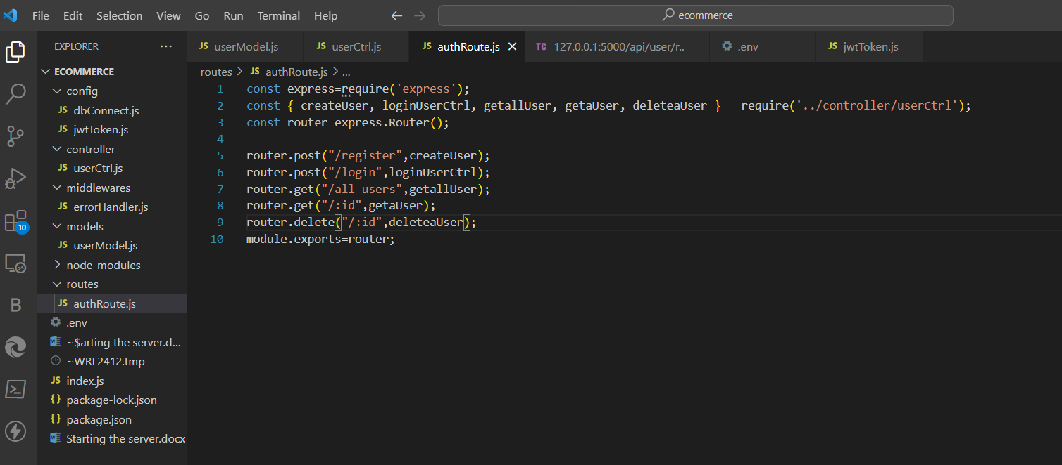

Update a user

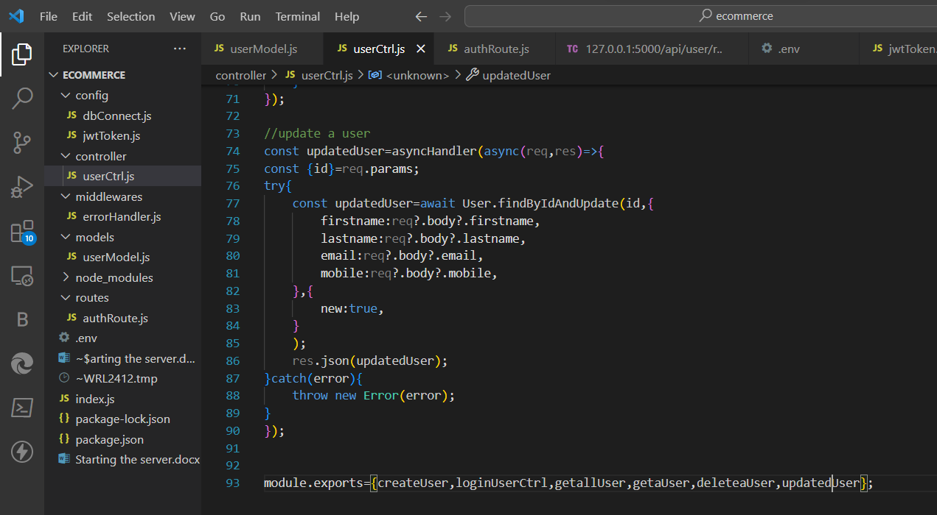

Route for the same

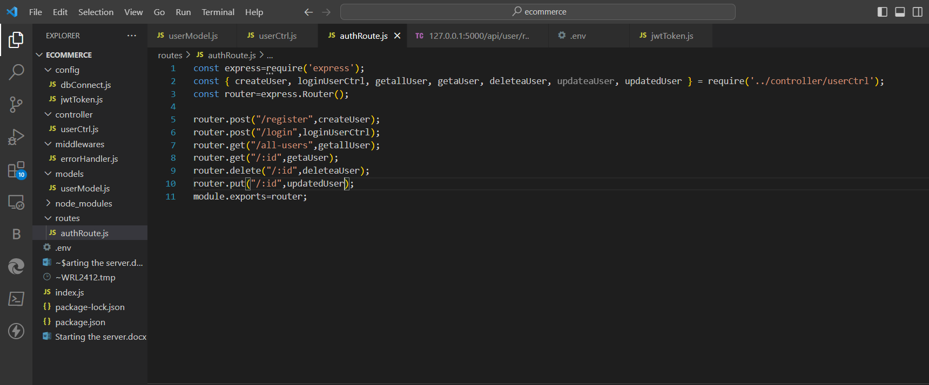

Update the models part for next process

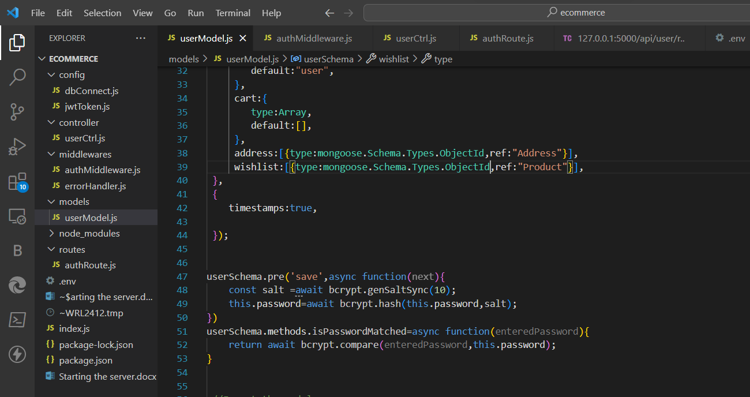

Working on jwt token

Create a new middle ware

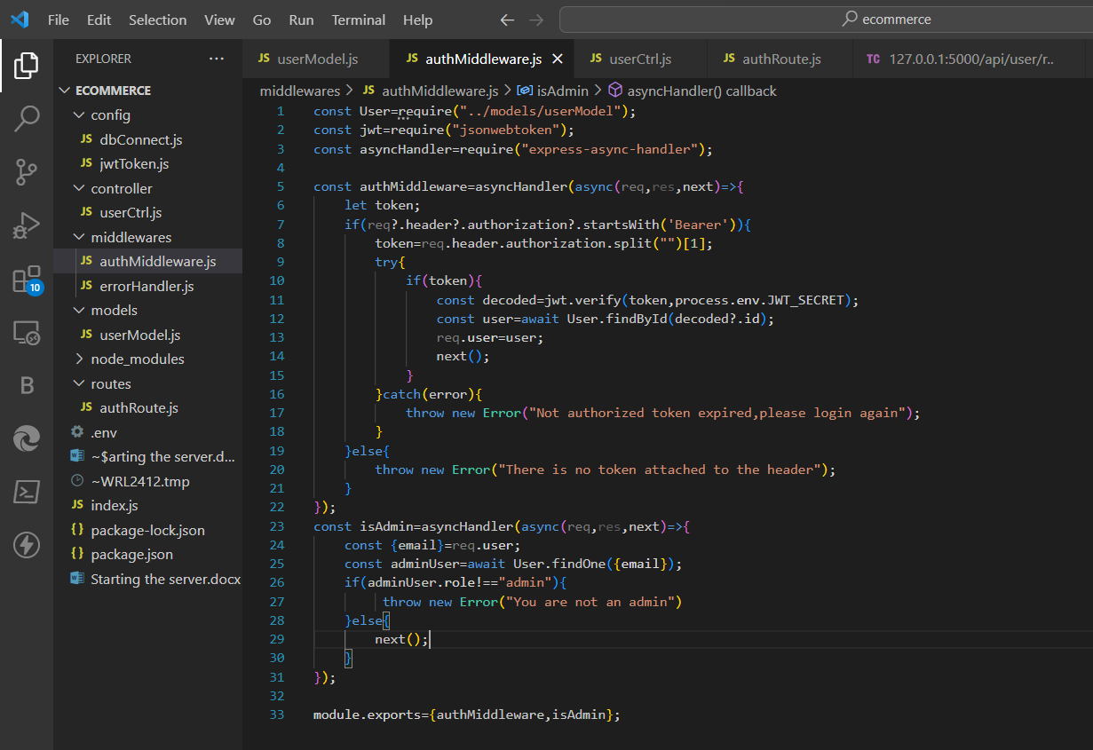

Update route also

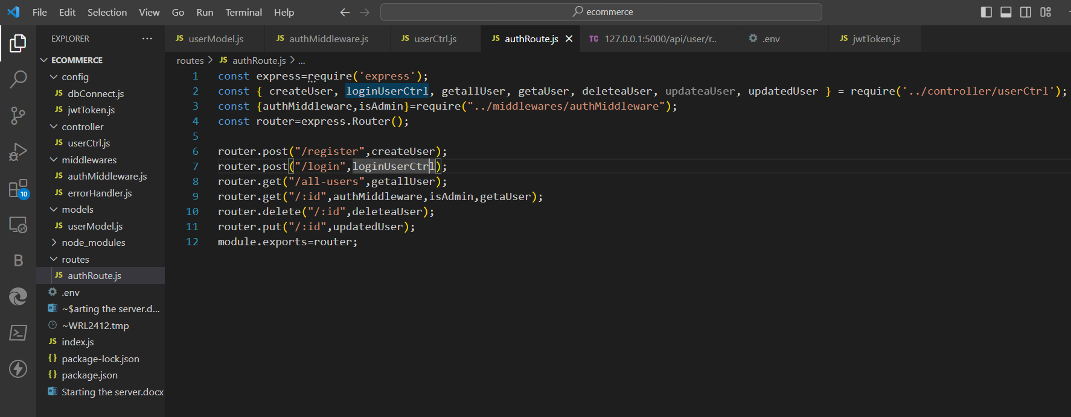

Update the user ctlr line 75

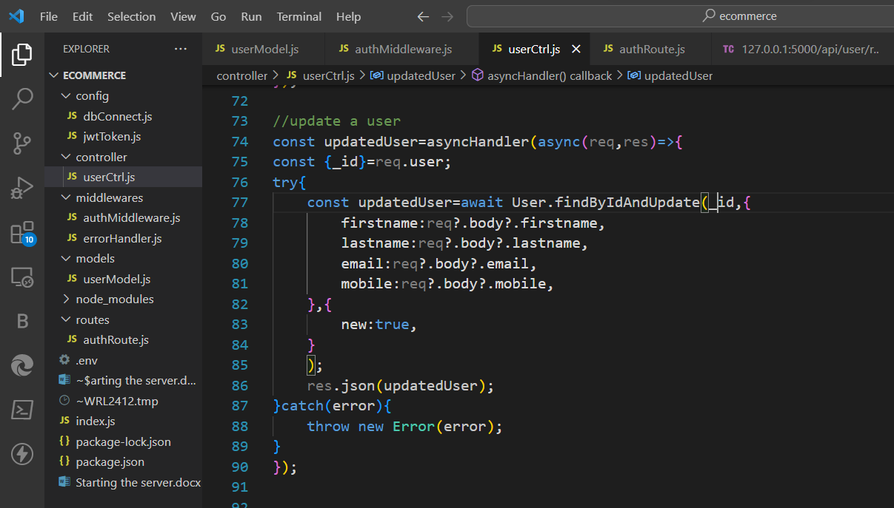

Update user model for block and unblock

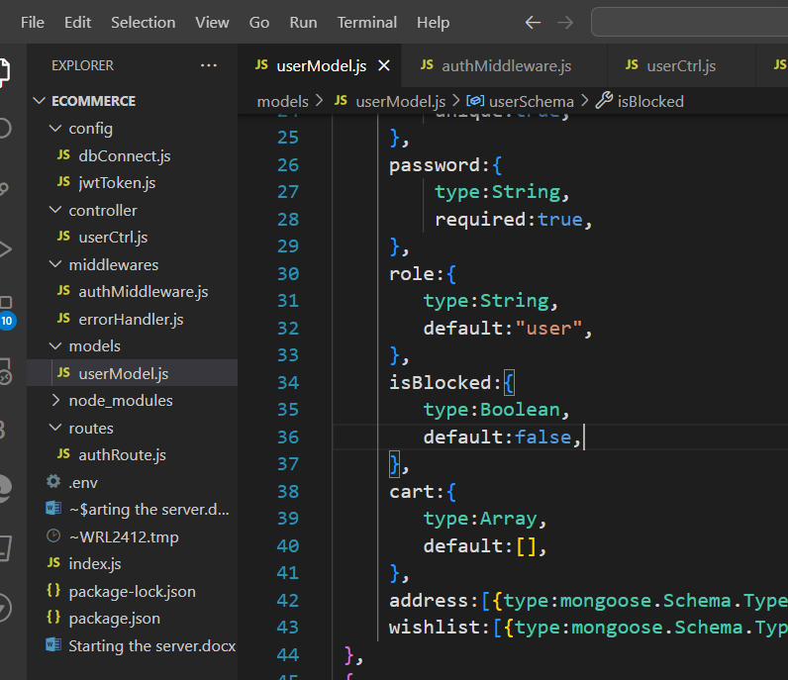

Update the routes also

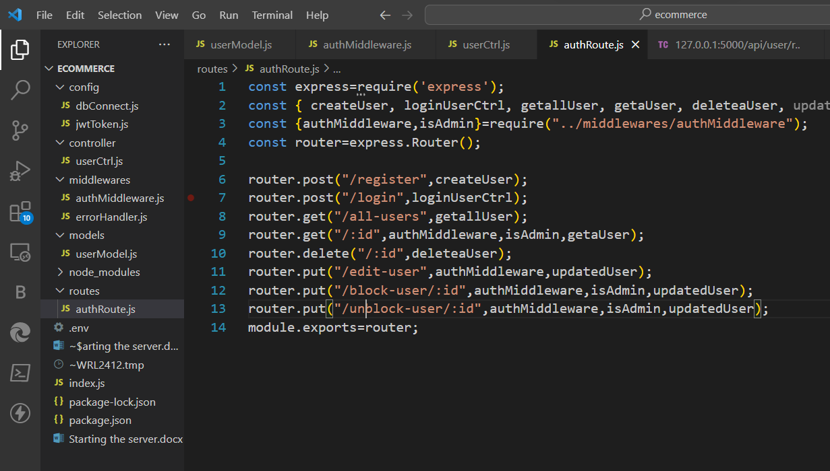

Update user ctrl for block add await for both block and unblock

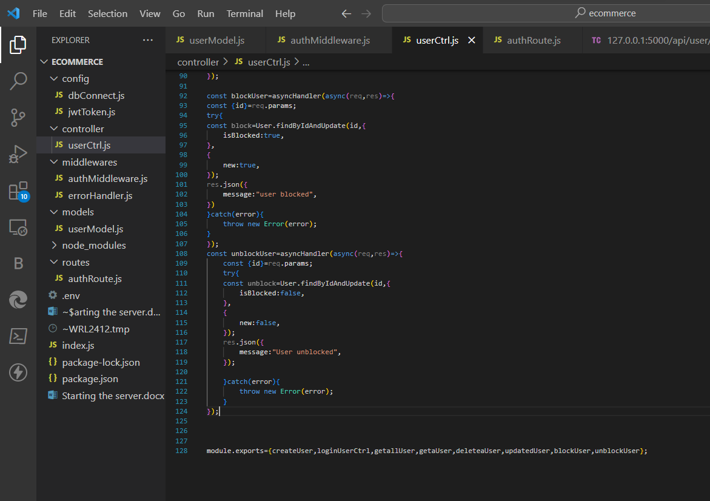

Update routes

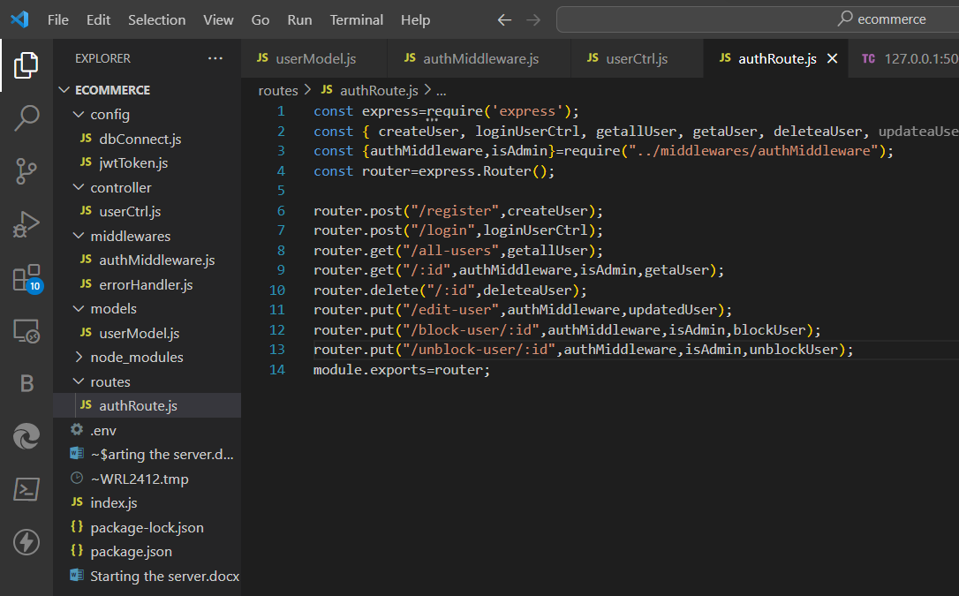

Create new folder utils with file name validateMongodlbd

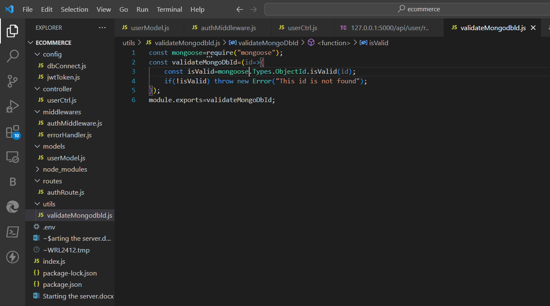

Userctrl update add validateMongoDbId(id) in all update and block and all

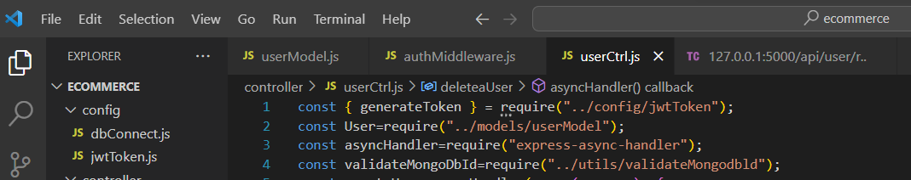

Authentication

Install cookie parser

npm I cookie-parser

update userModel

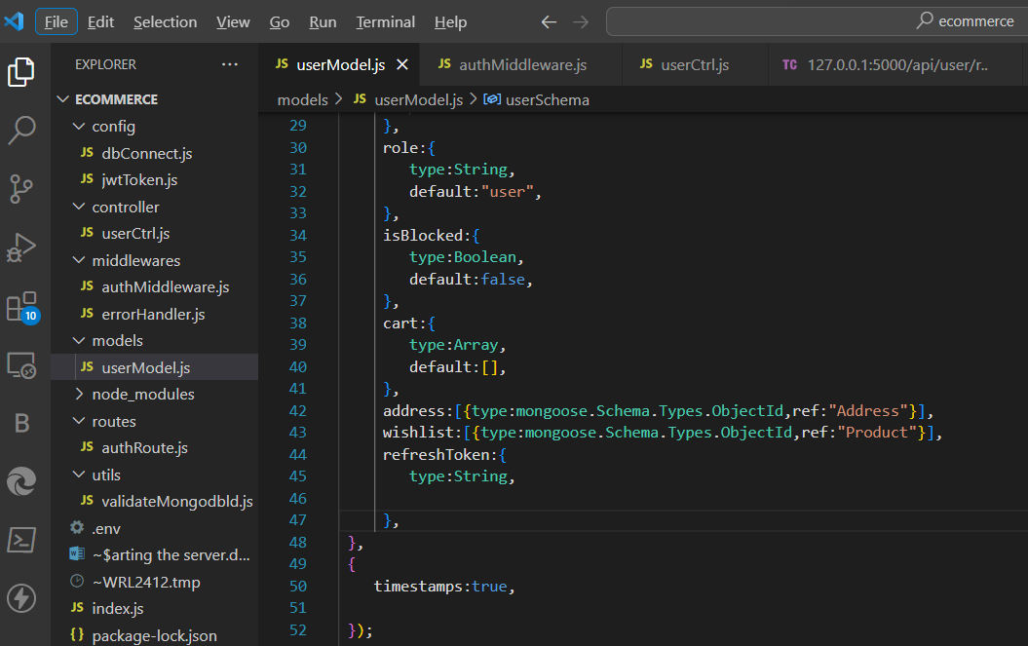

Update index.js line 9,20

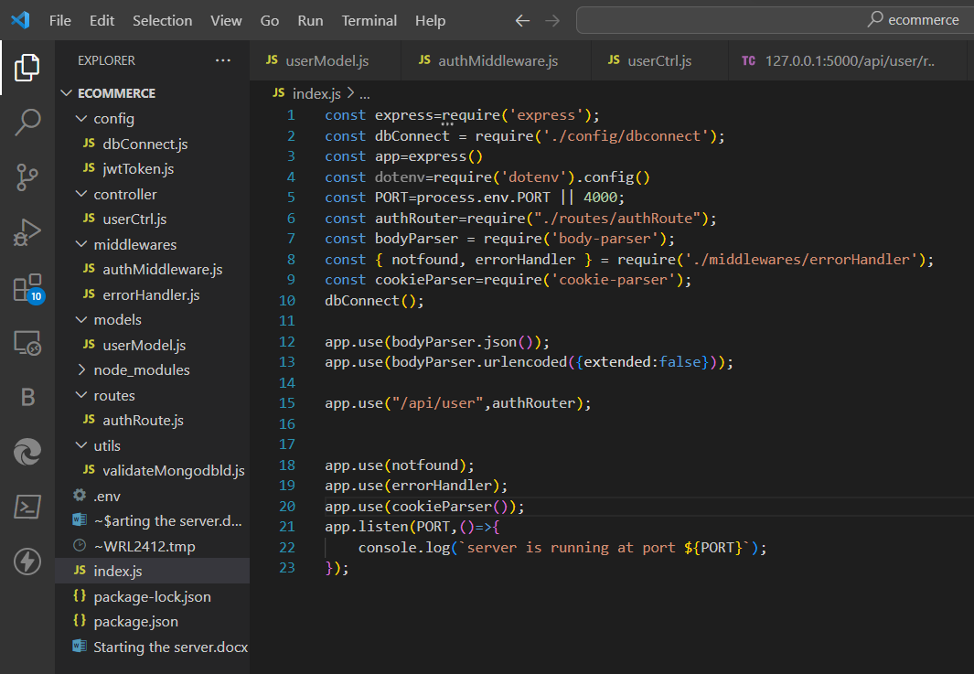

Create a new file in config

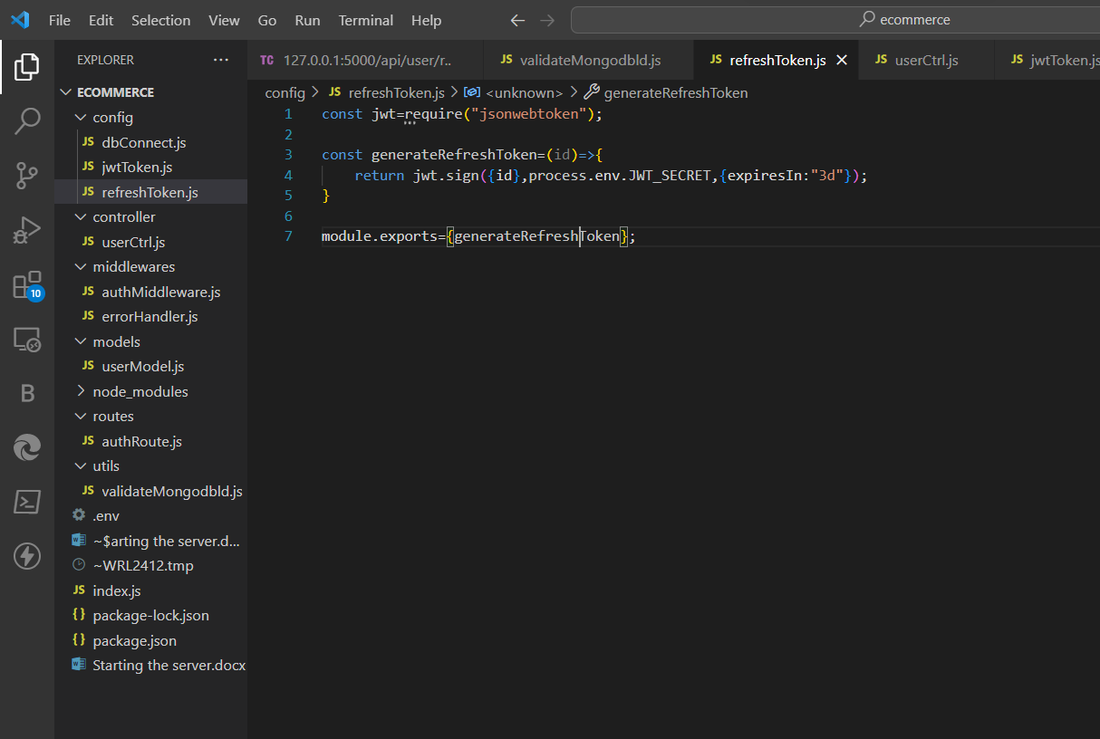

Handle refresh token in userctrl 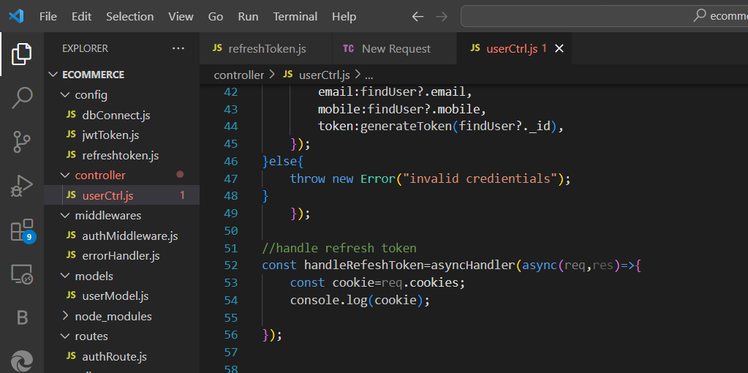

Add is route

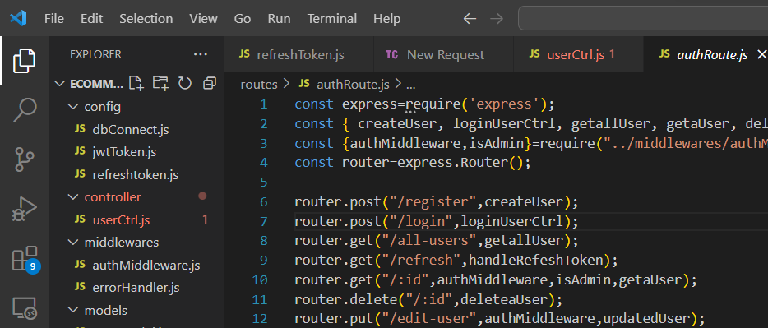

Finding user from refresh token and handling refresh token

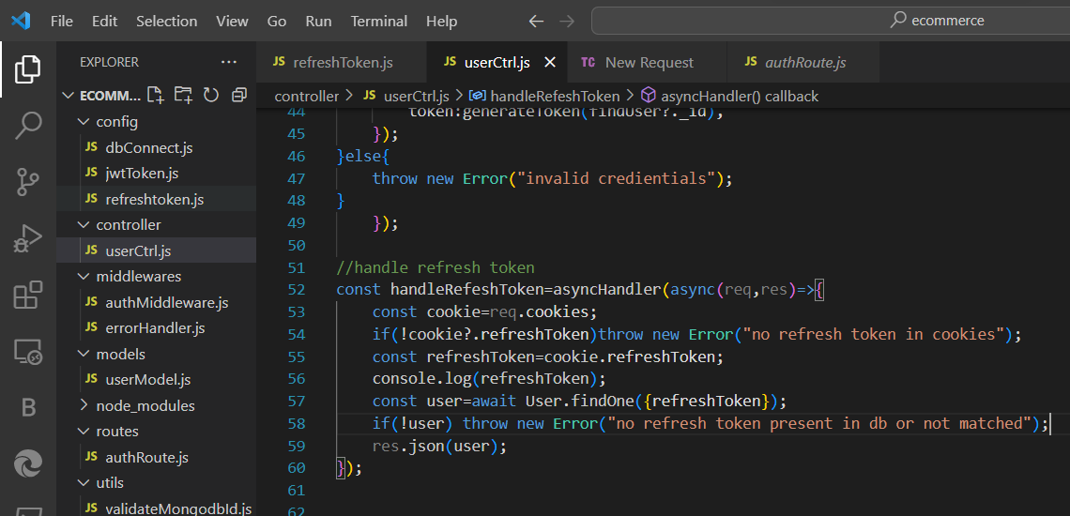

We need to verify it after finding the refresh token and update handle refresh token part

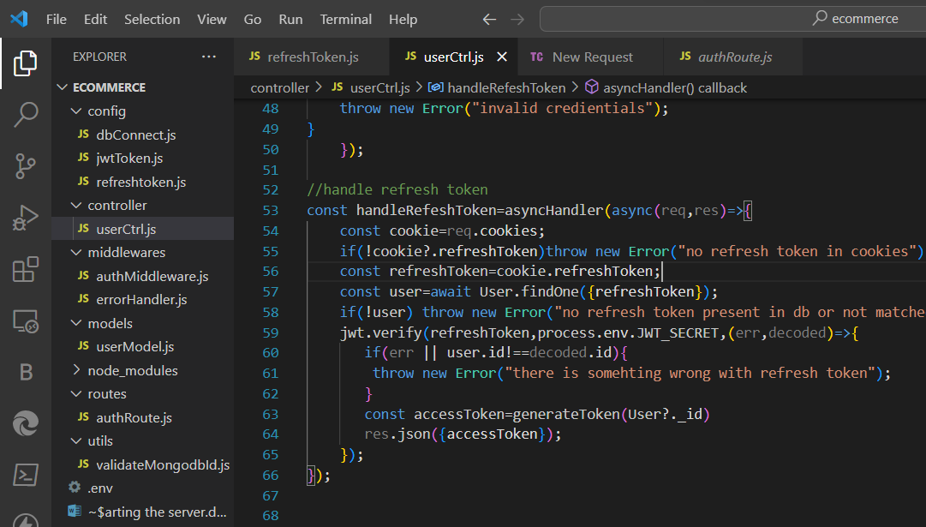

Logout a user

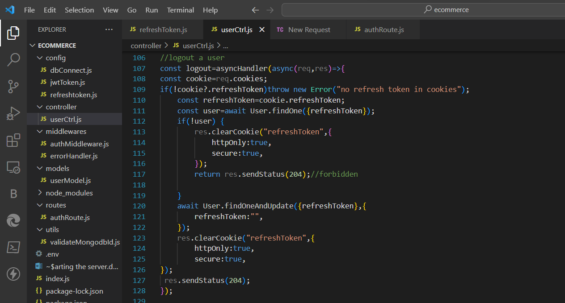

Add route line 10

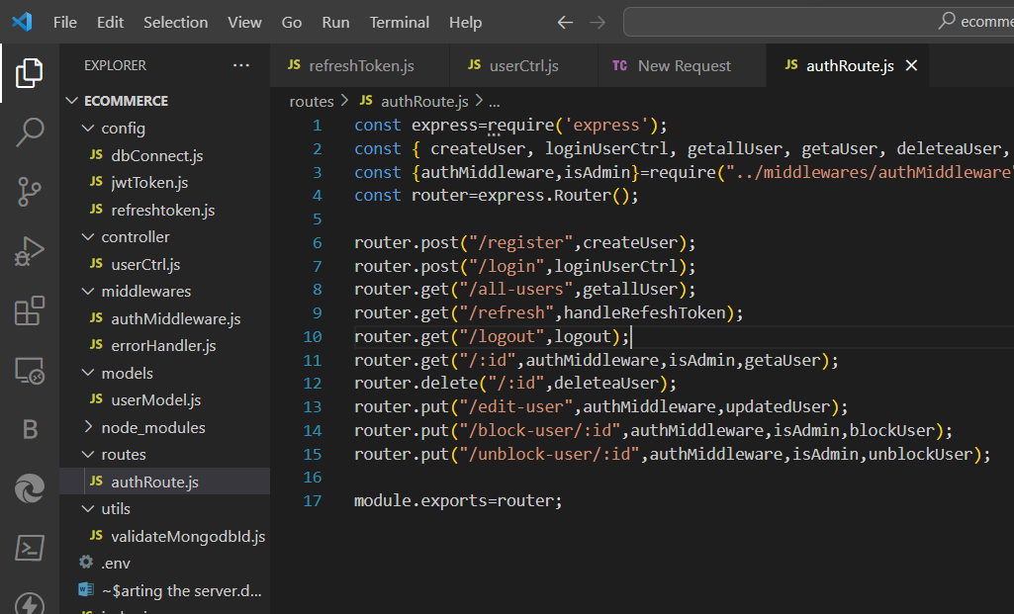

Now making productModel.js

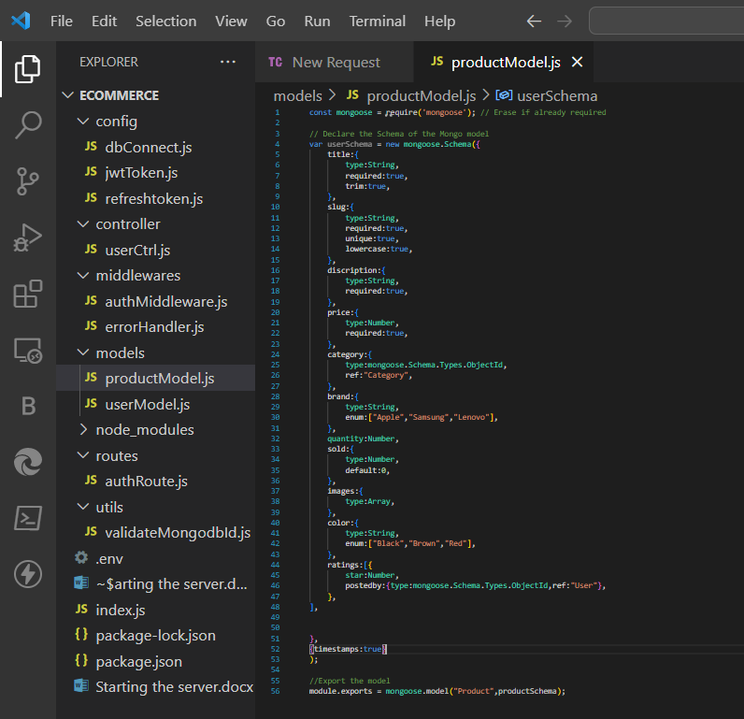

Create a new ctrl productCtrl.js and productRoute.js

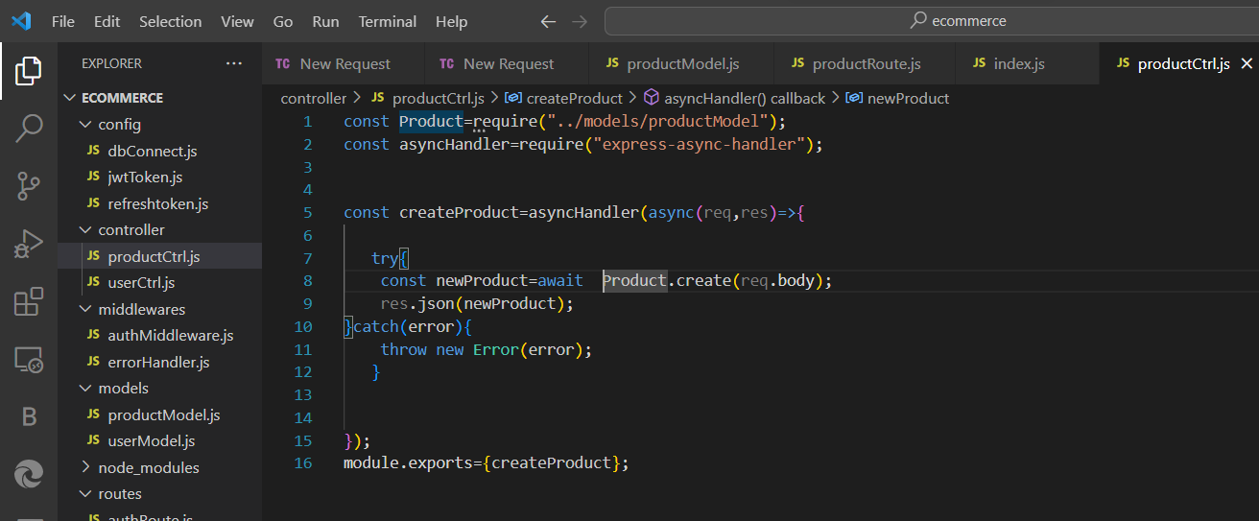

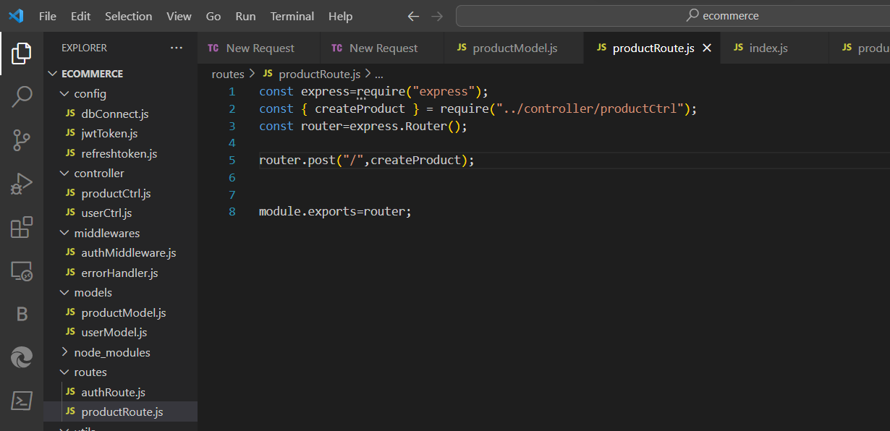

Now create a product

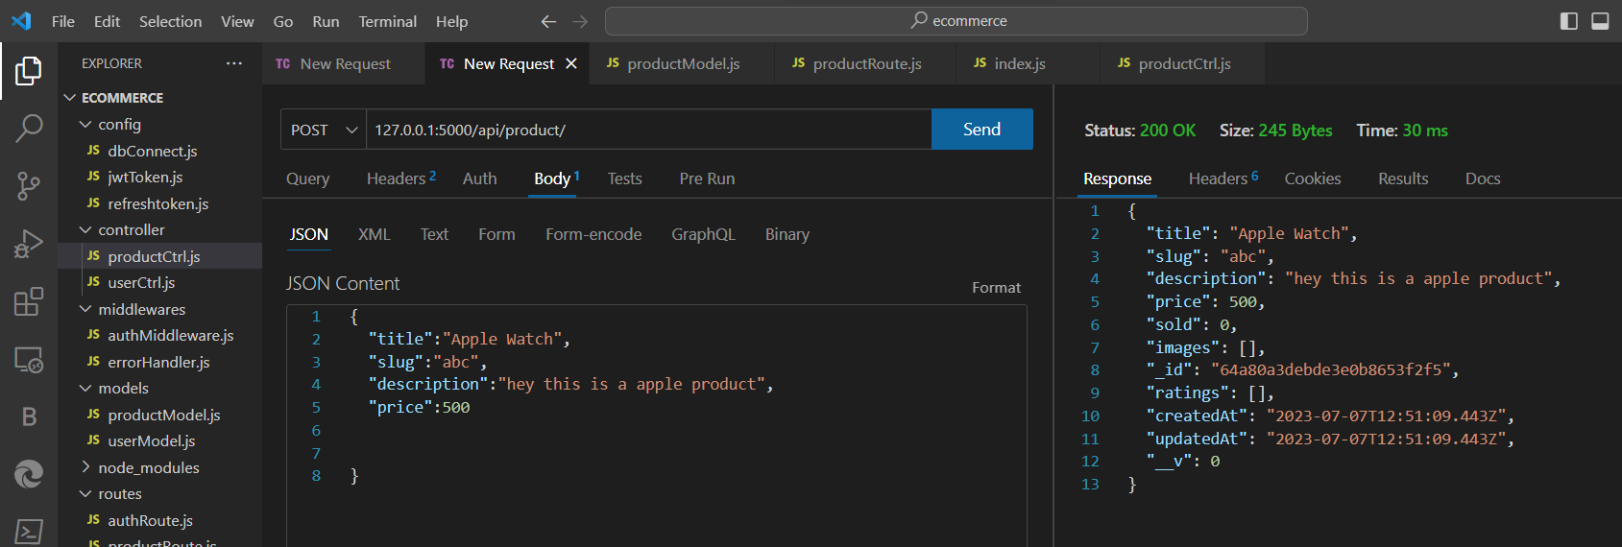

Update product model

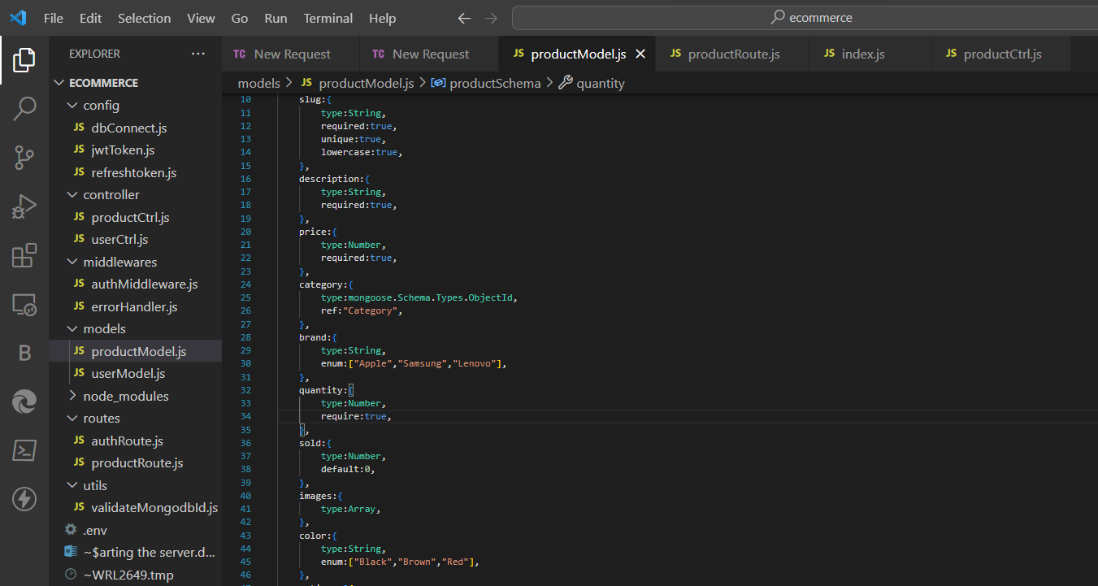

Create a product ctrl for getting a product

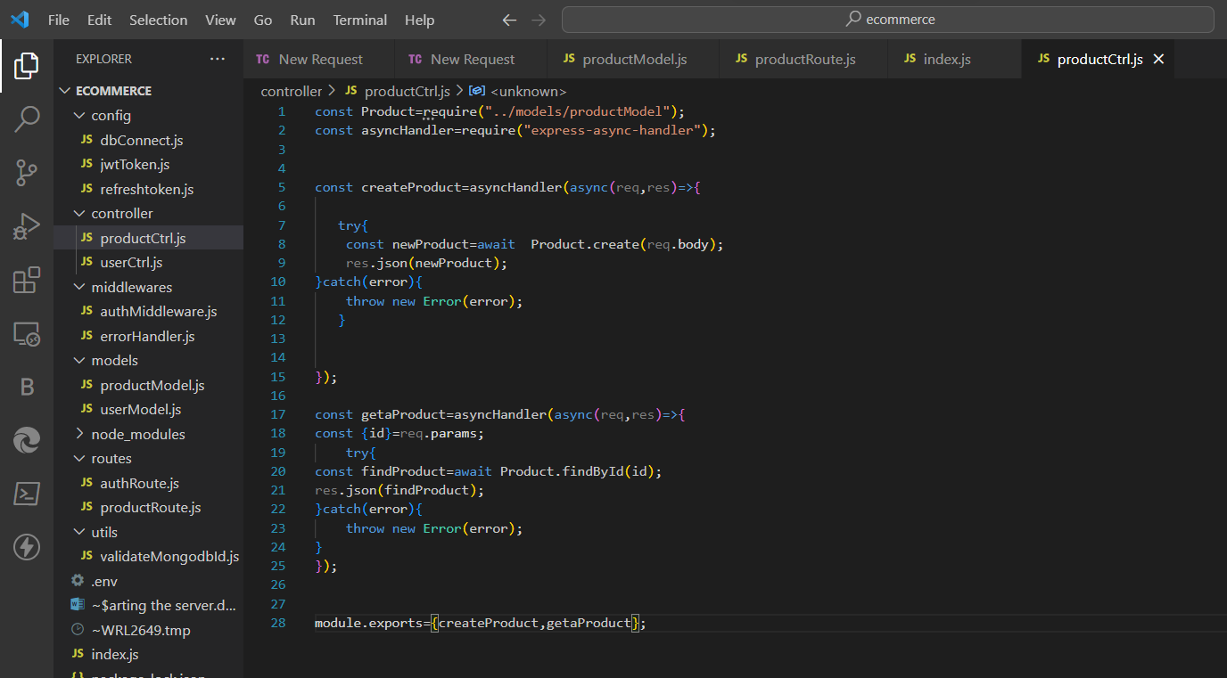

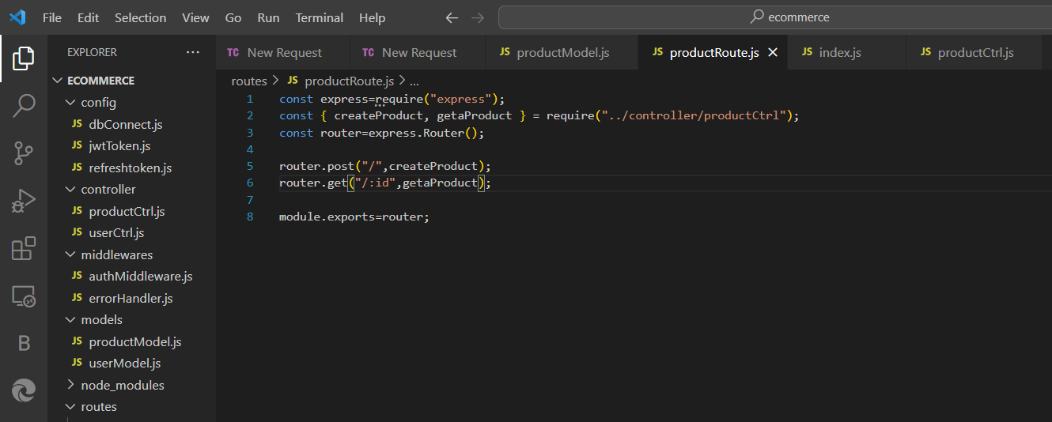

Add one more controller

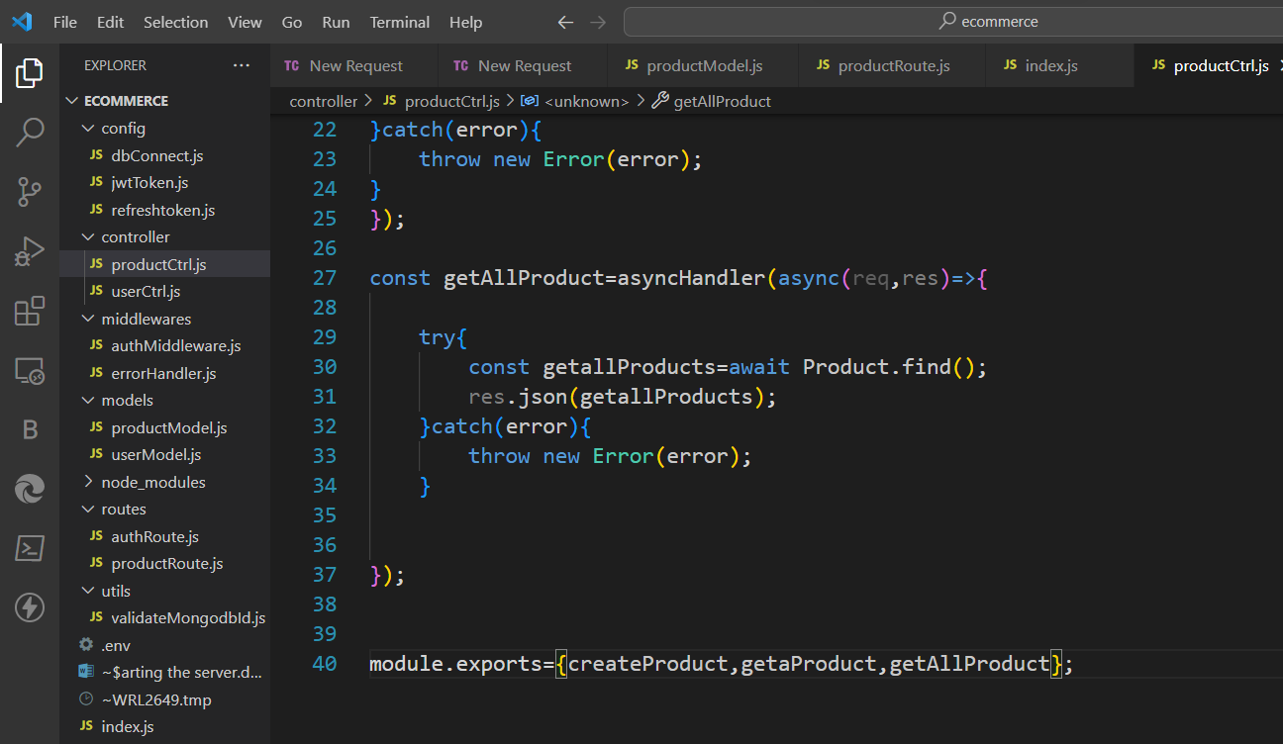

And its route

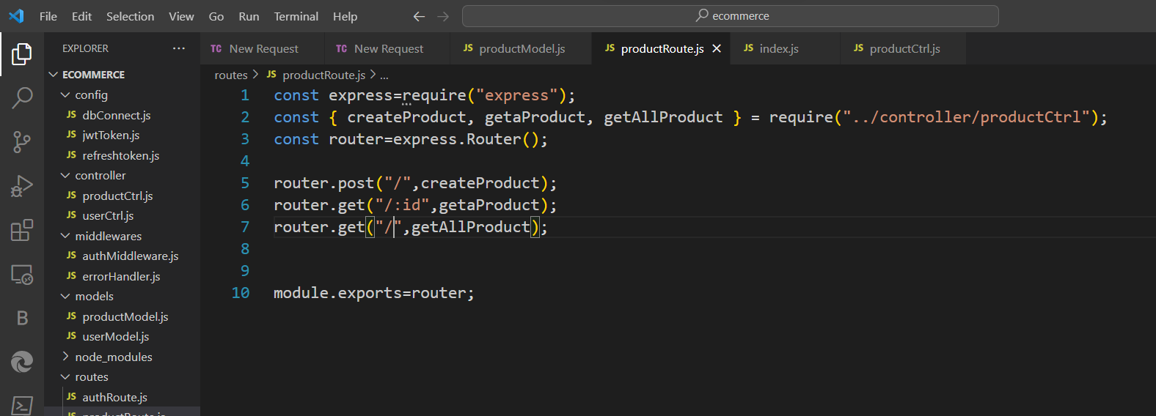

Update the productModel

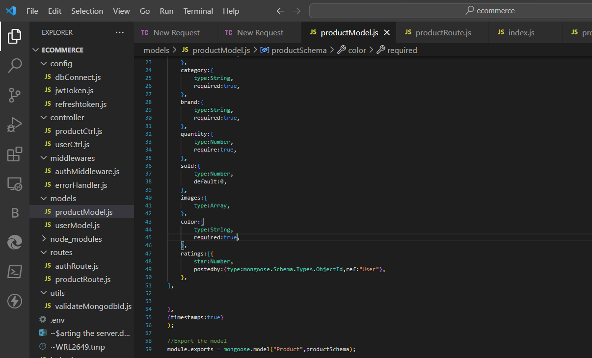

Install more modules

npm I morgan-helps in getting all the request and queries in the terminal

now go to index.js on line 14 inside bracket do add “dev”

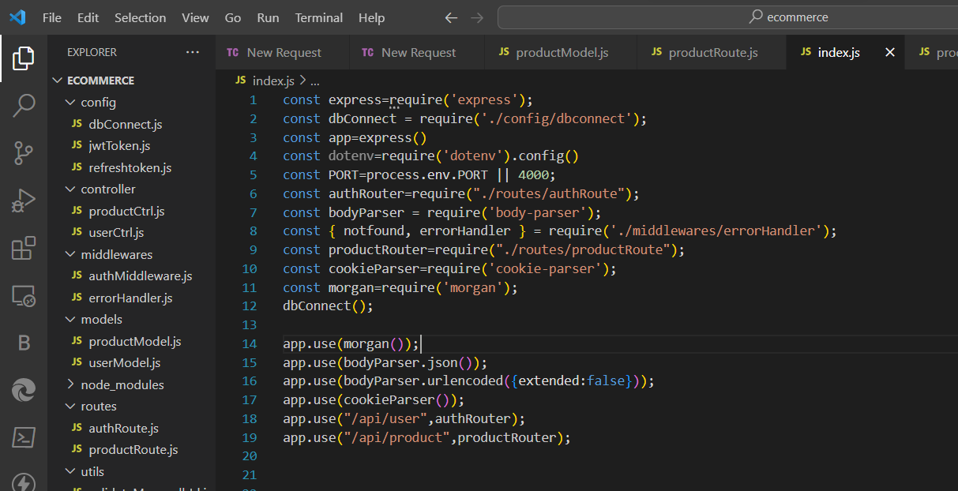

Results om using morgan see terminal

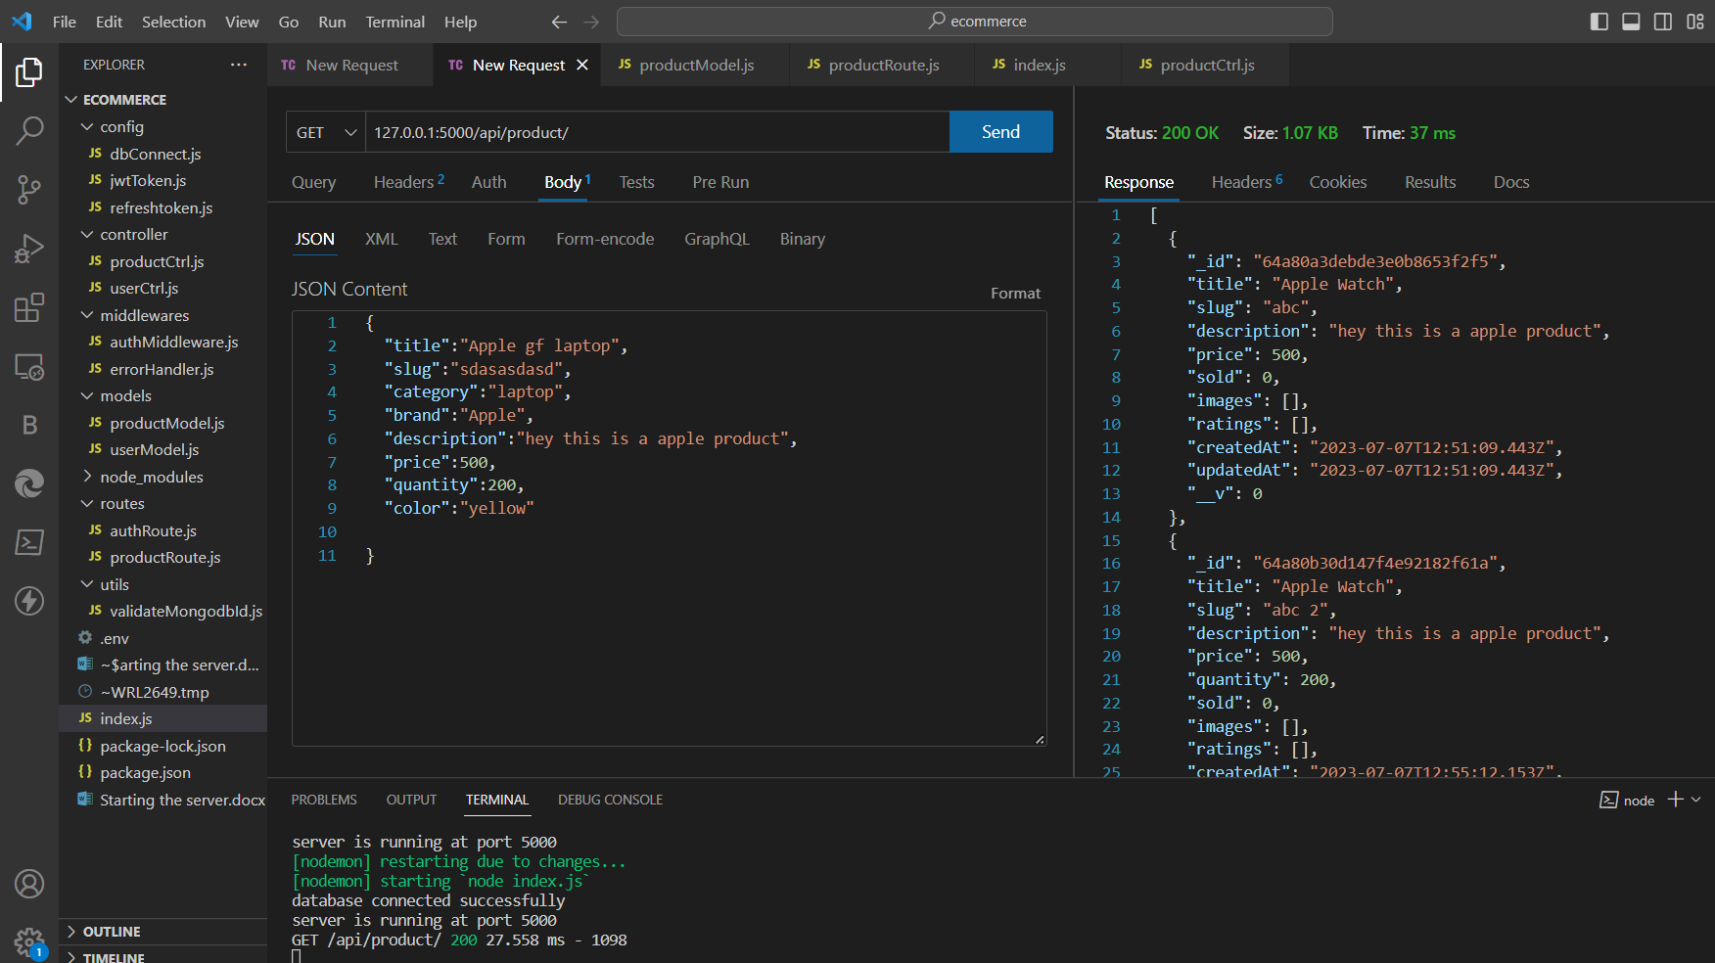

Now install slugify

npm i slugify

now update product controller

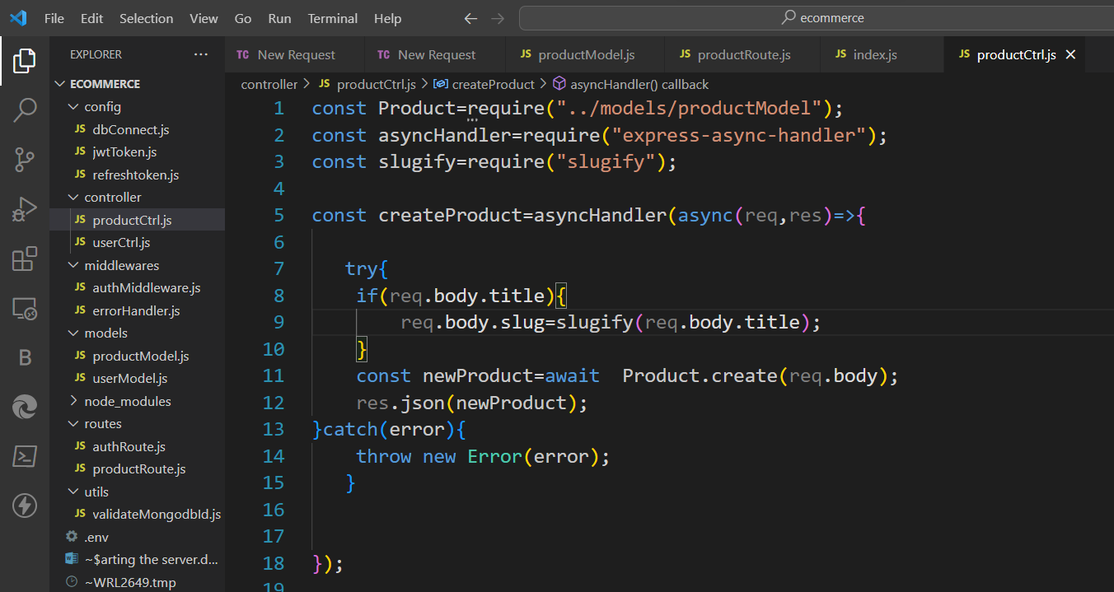

Results of slugify

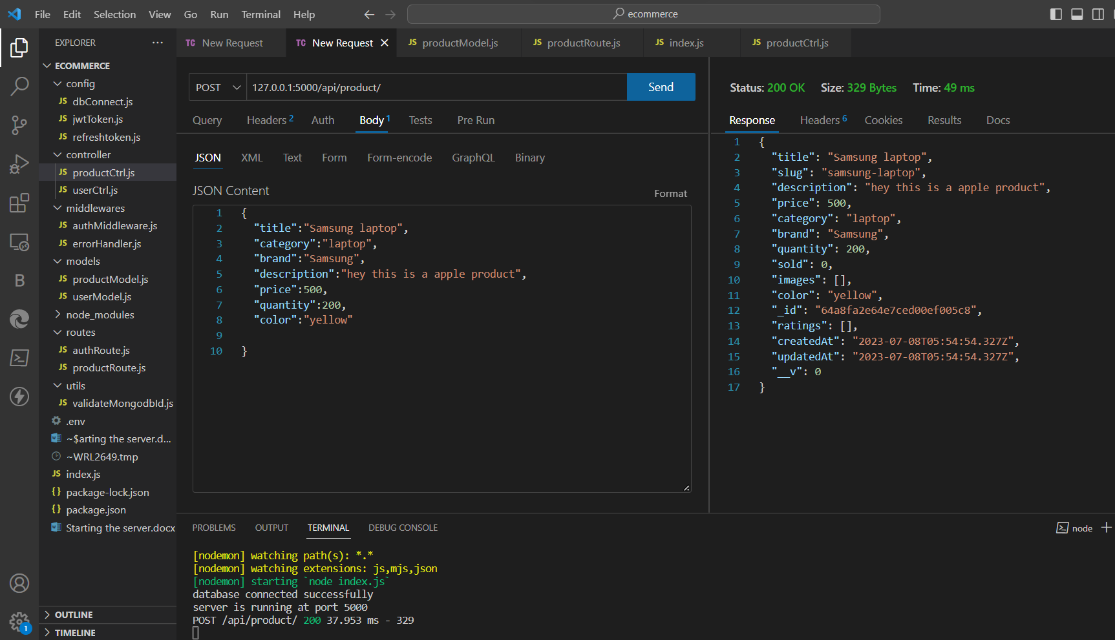

Now create product updation part

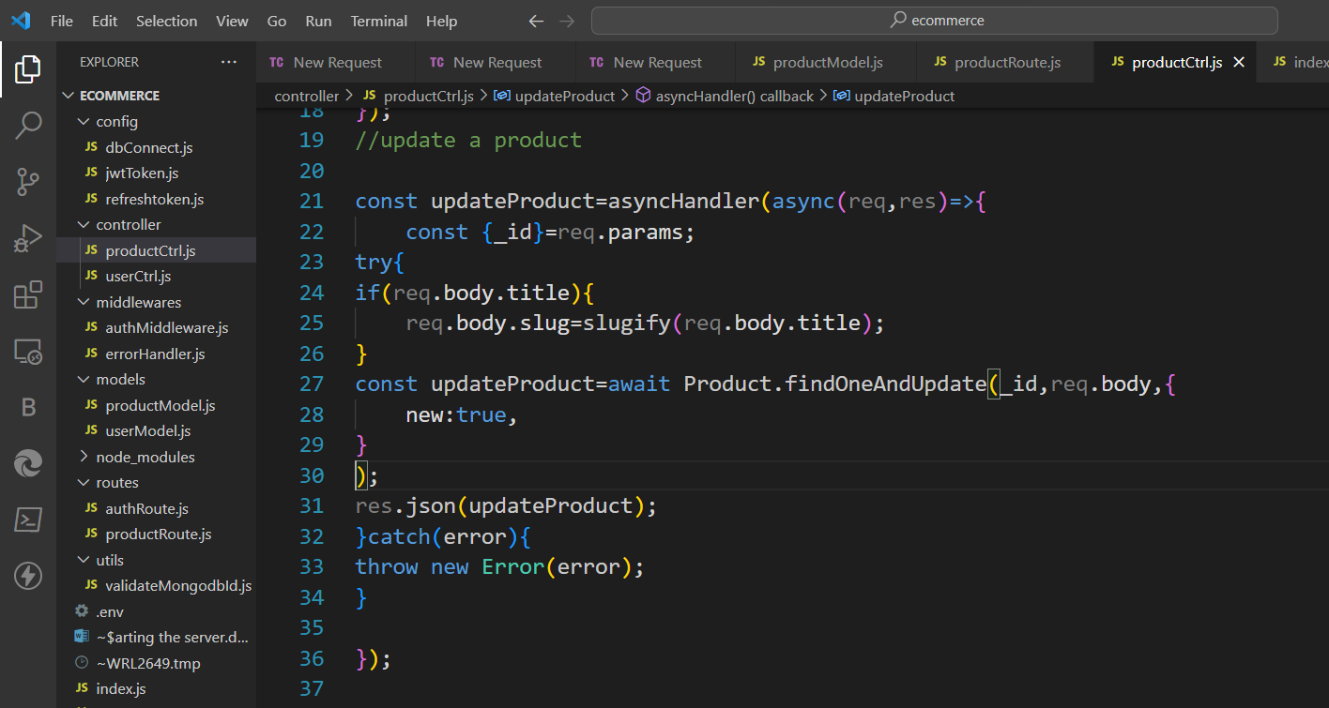

Route

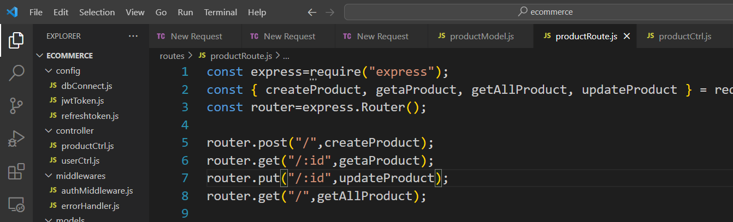

Now deleting the product

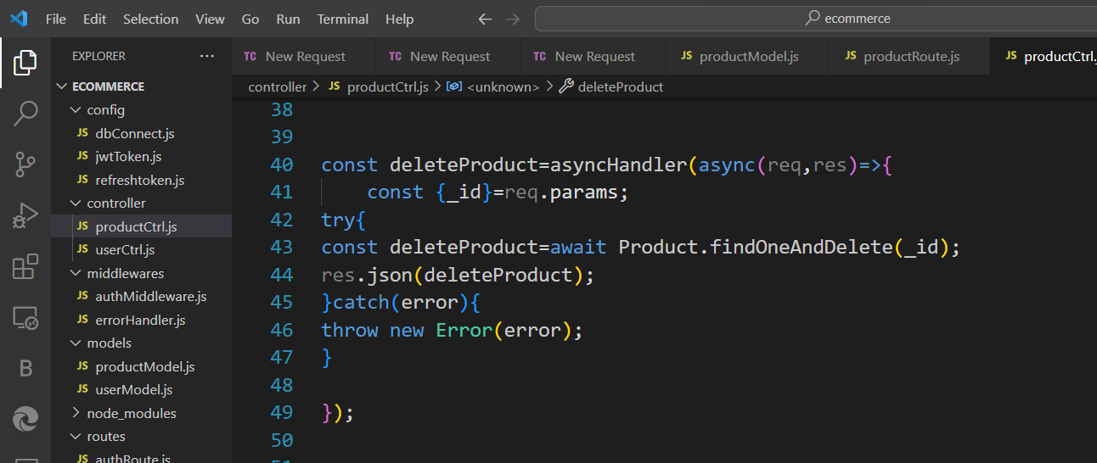

Route

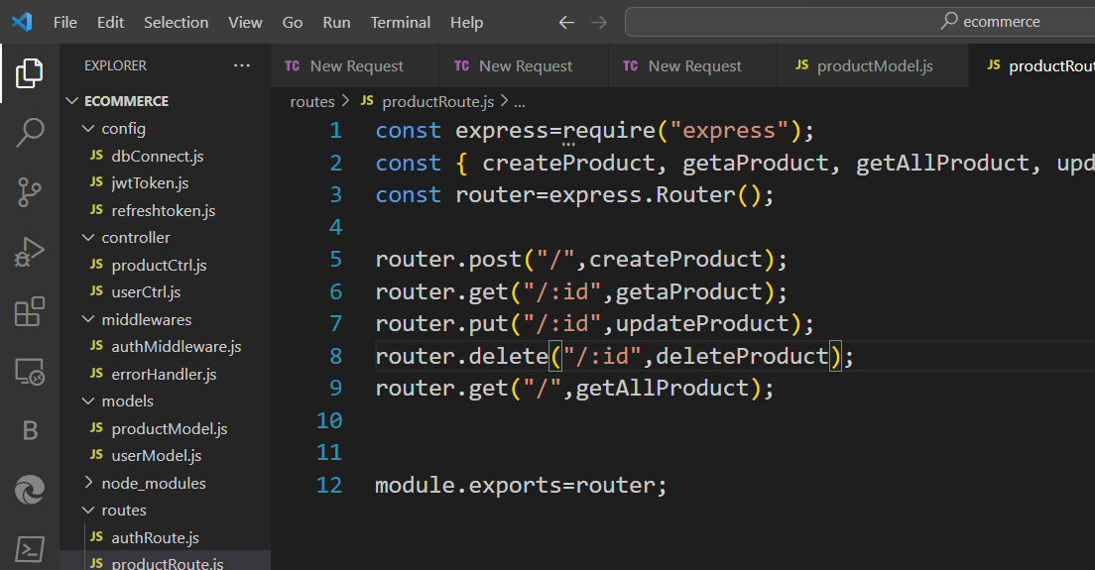

Exports the middle in route of product that if isadmin then only can delete

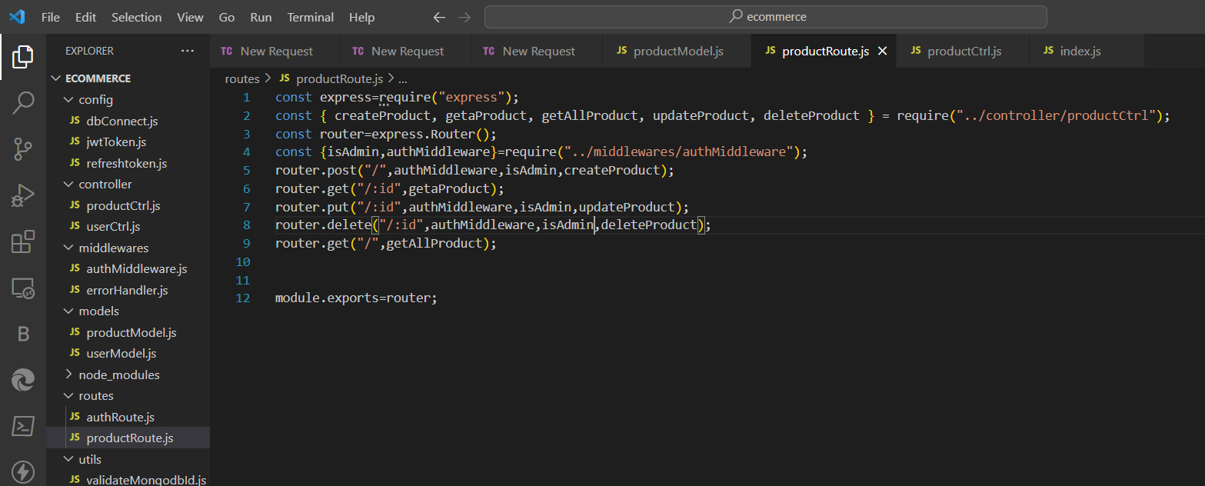

Now lets hide information from user go to productModel use select:false

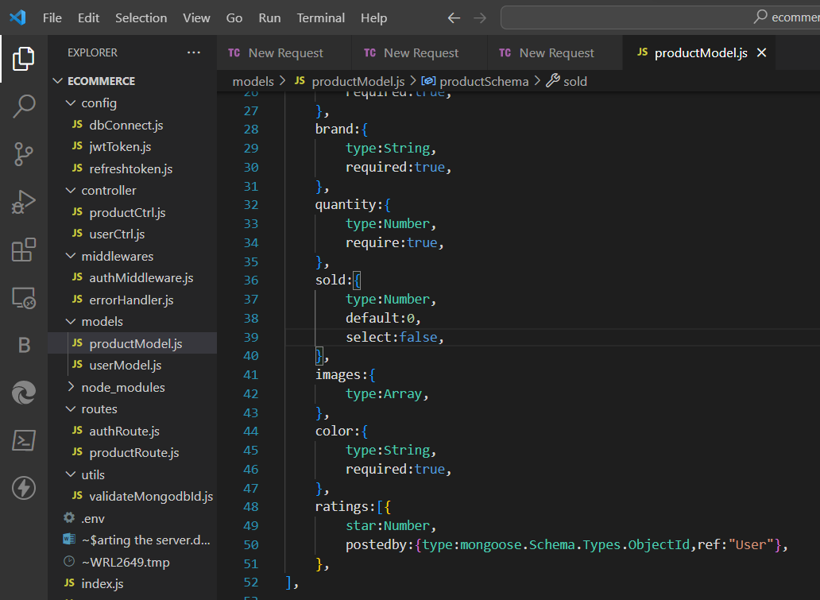

Update produvt controller part and get all product

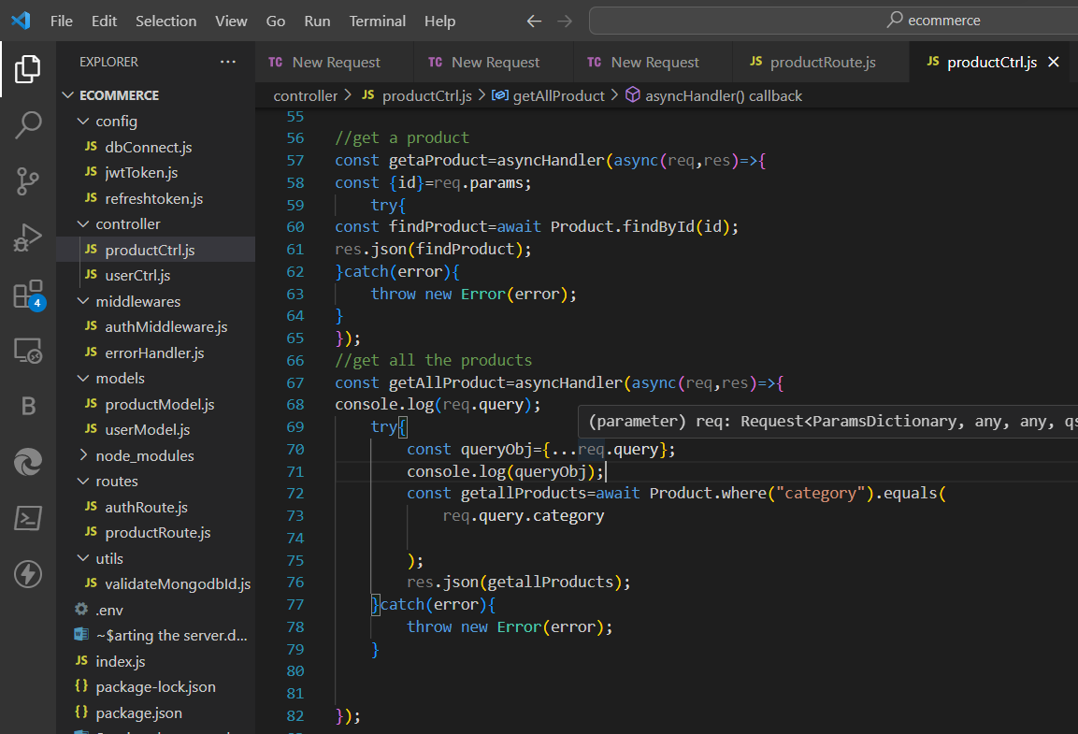

Lets do filtering process in get all product part

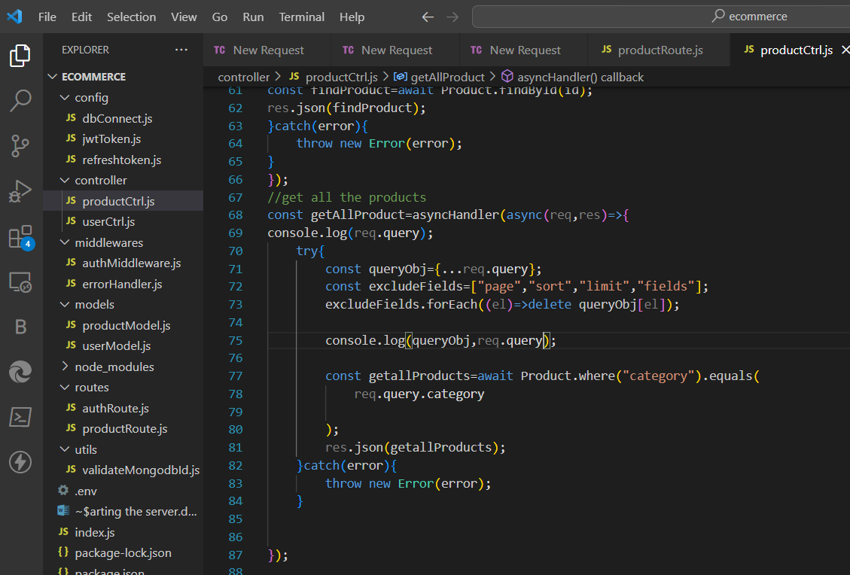

Now for doing price less than greater than part for getting product in desired range(product filtering)

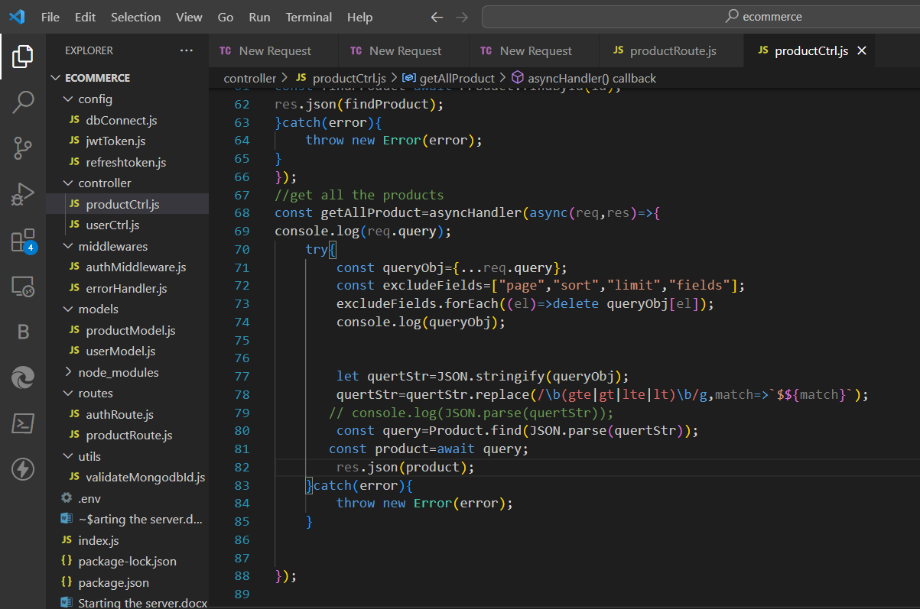

Sorting part now do update line 81

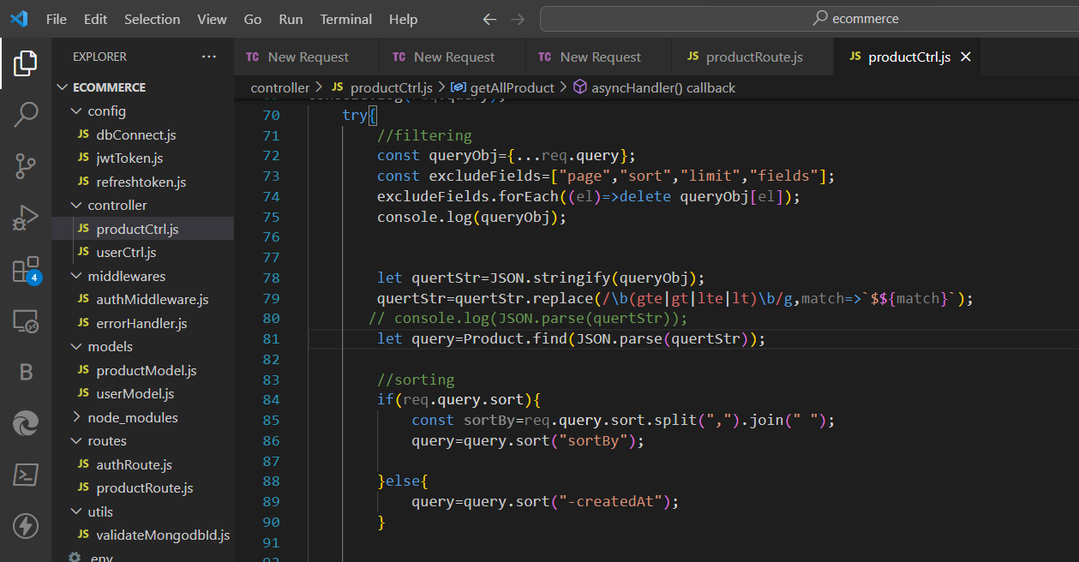

Limiting the fields ‘-’ is used to make the line completely disappear

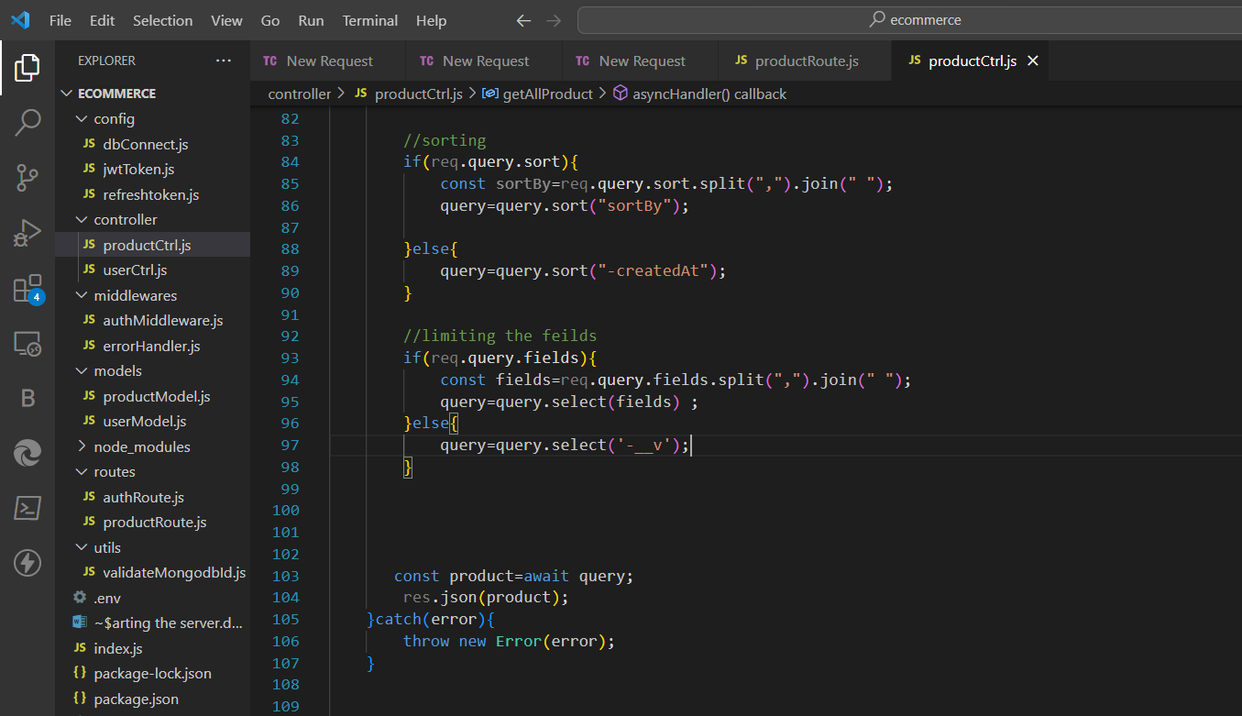

Pagination part

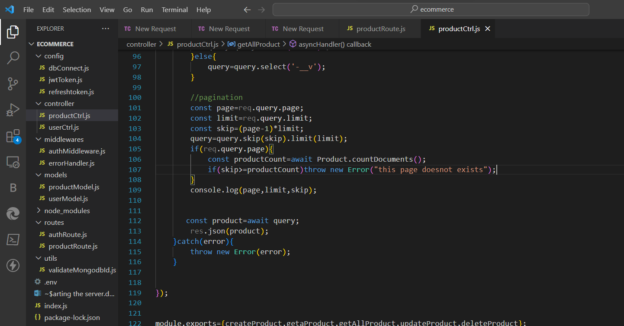

Update reset password using email

Update the userModel

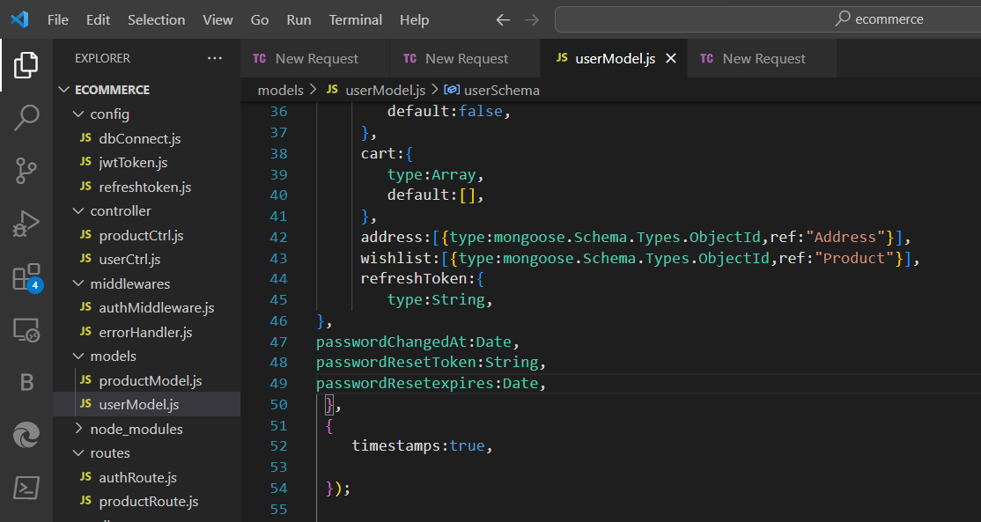

Again encrypt the password after reseting it and add import crypto using npm i crypto

const crypto=require(“crypto”);

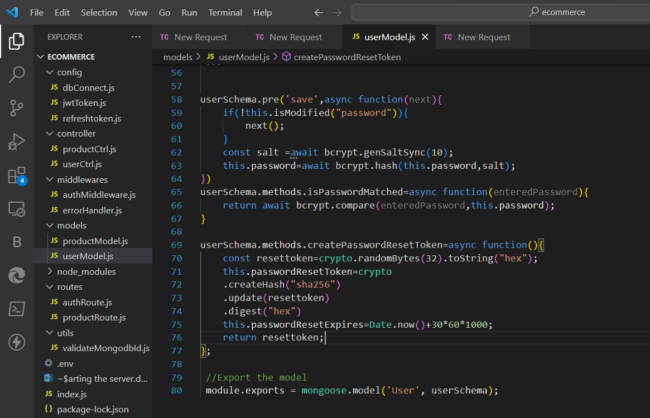

Now move to userCtl and do the same (some error that password is not getting updated)

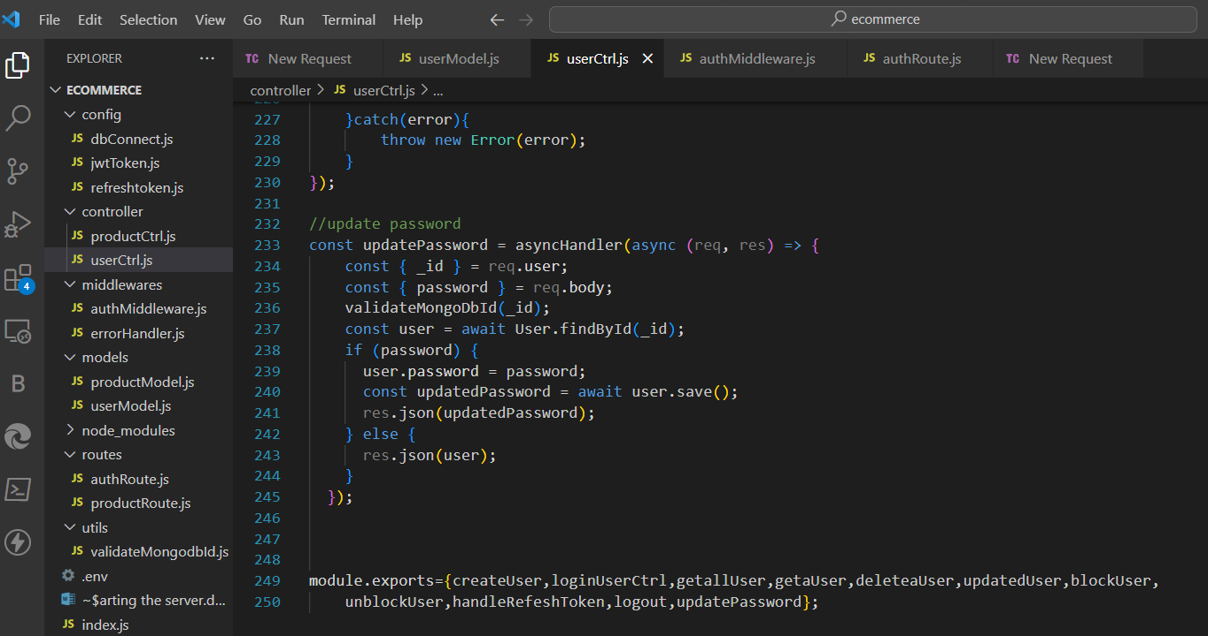

Install nodemailer

npm i nodemailer